ASSIGNMENT-8

NAME-KONAKALLA AKHILA ROLL NUMBER-DXC262AB1225

BATCH-DXC-262-ANALYTICS-B12-AZURE

COMPANY-DXC TECHNOLOGY

EMPLOYEE DOMAIN-AZURE ANALYTICS

TRAINING UNDER-MANIPAL PRO LEARN

TRAINER NAME-MR.AJAY KUMAR

DATE OF SUBMISSION -8th JUNE 2022

**1.Explain the steps with screenshots how to create Blog storage in Azure cloud ?**

1.From the left portal menu, select **Storage accounts** to display a list of your storage accounts. If the portal menu isn't visible, click the menu button to toggle it on.

2.On the **Storage accounts** page, select **Create.**

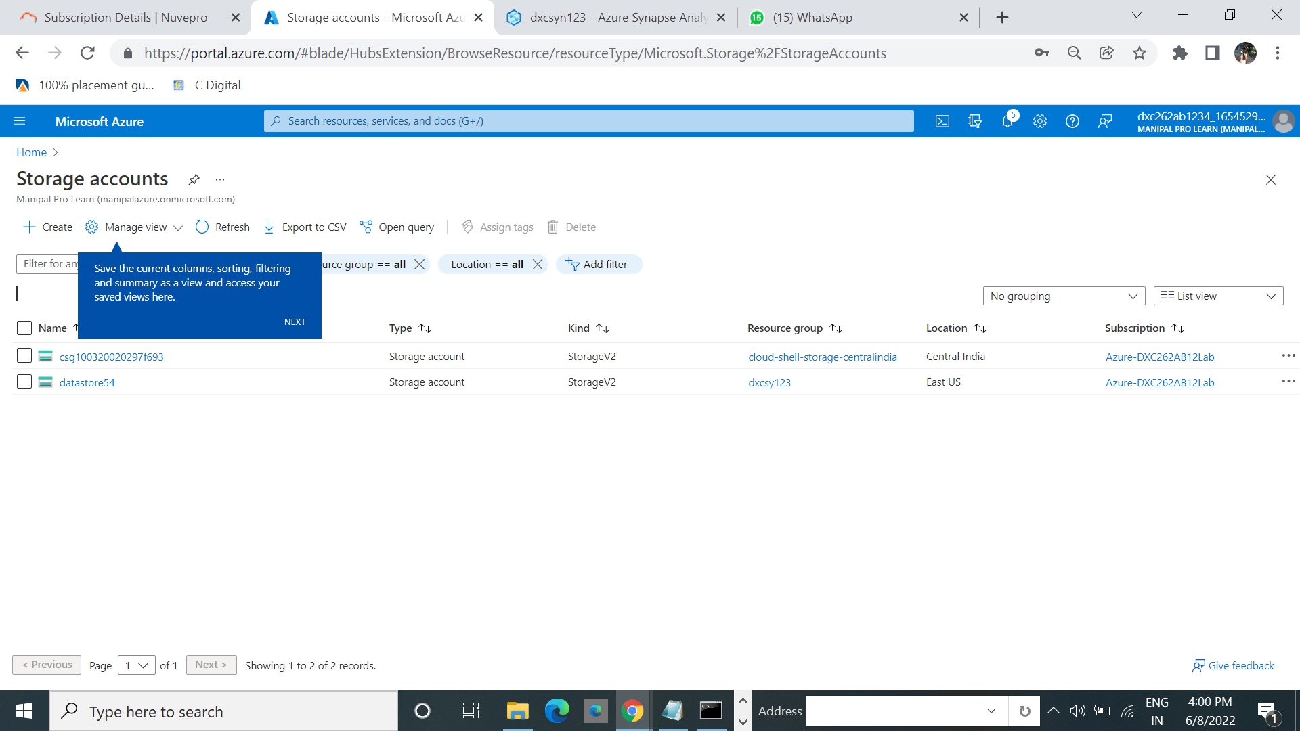

3.Write the resourse name

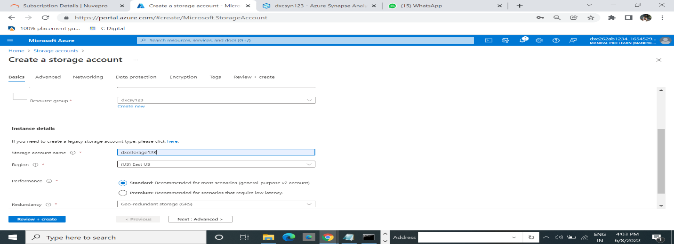

4.The following image shows a standard configuration of the advanced properties for a new storage account.

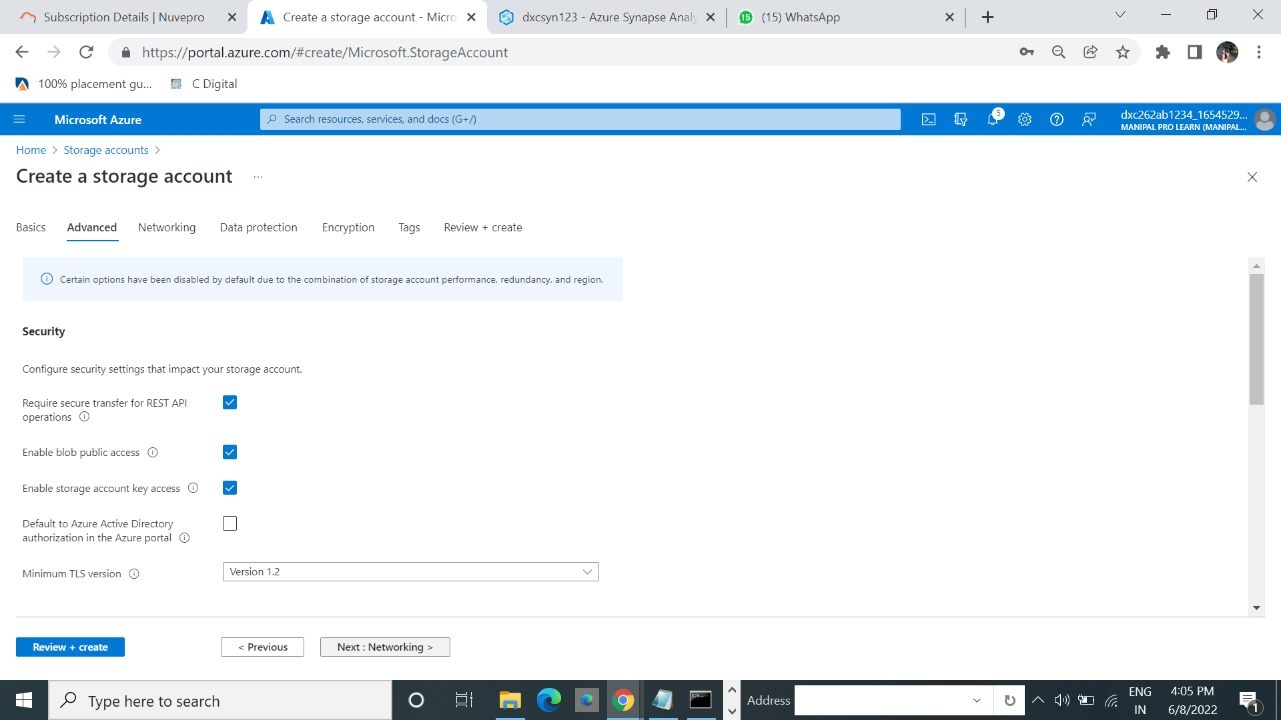

5.On the **Networking** tab, you can configure network connectivity and routing preference settings for your new storage account.

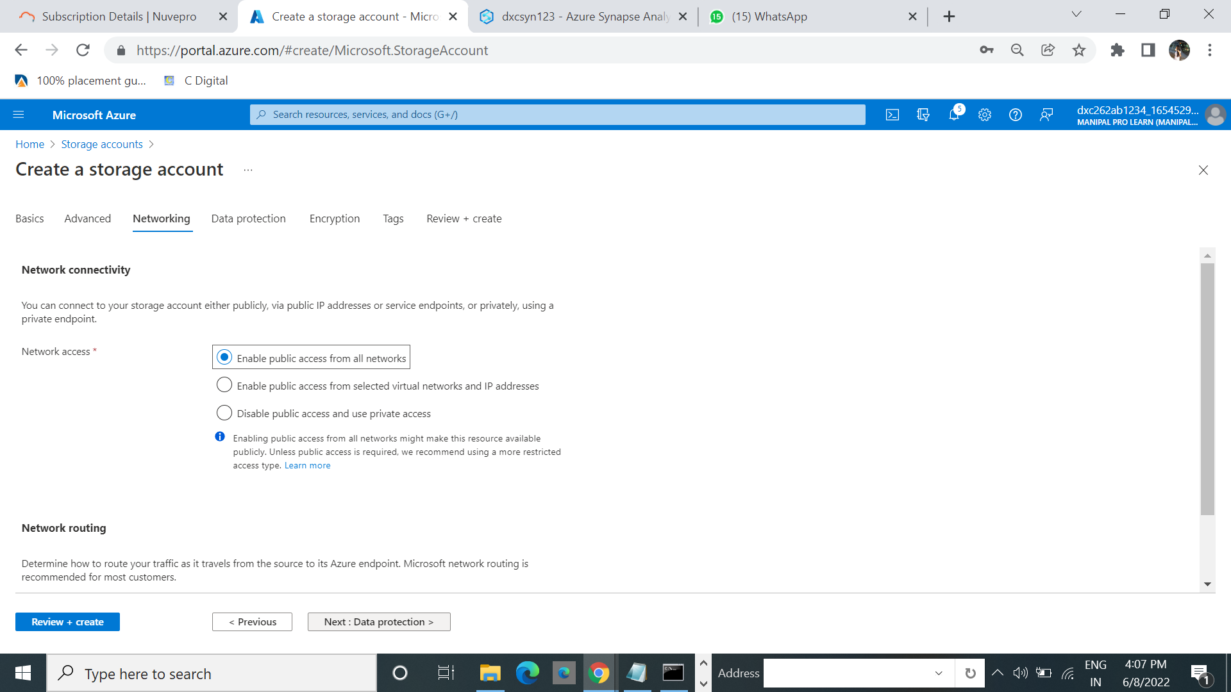

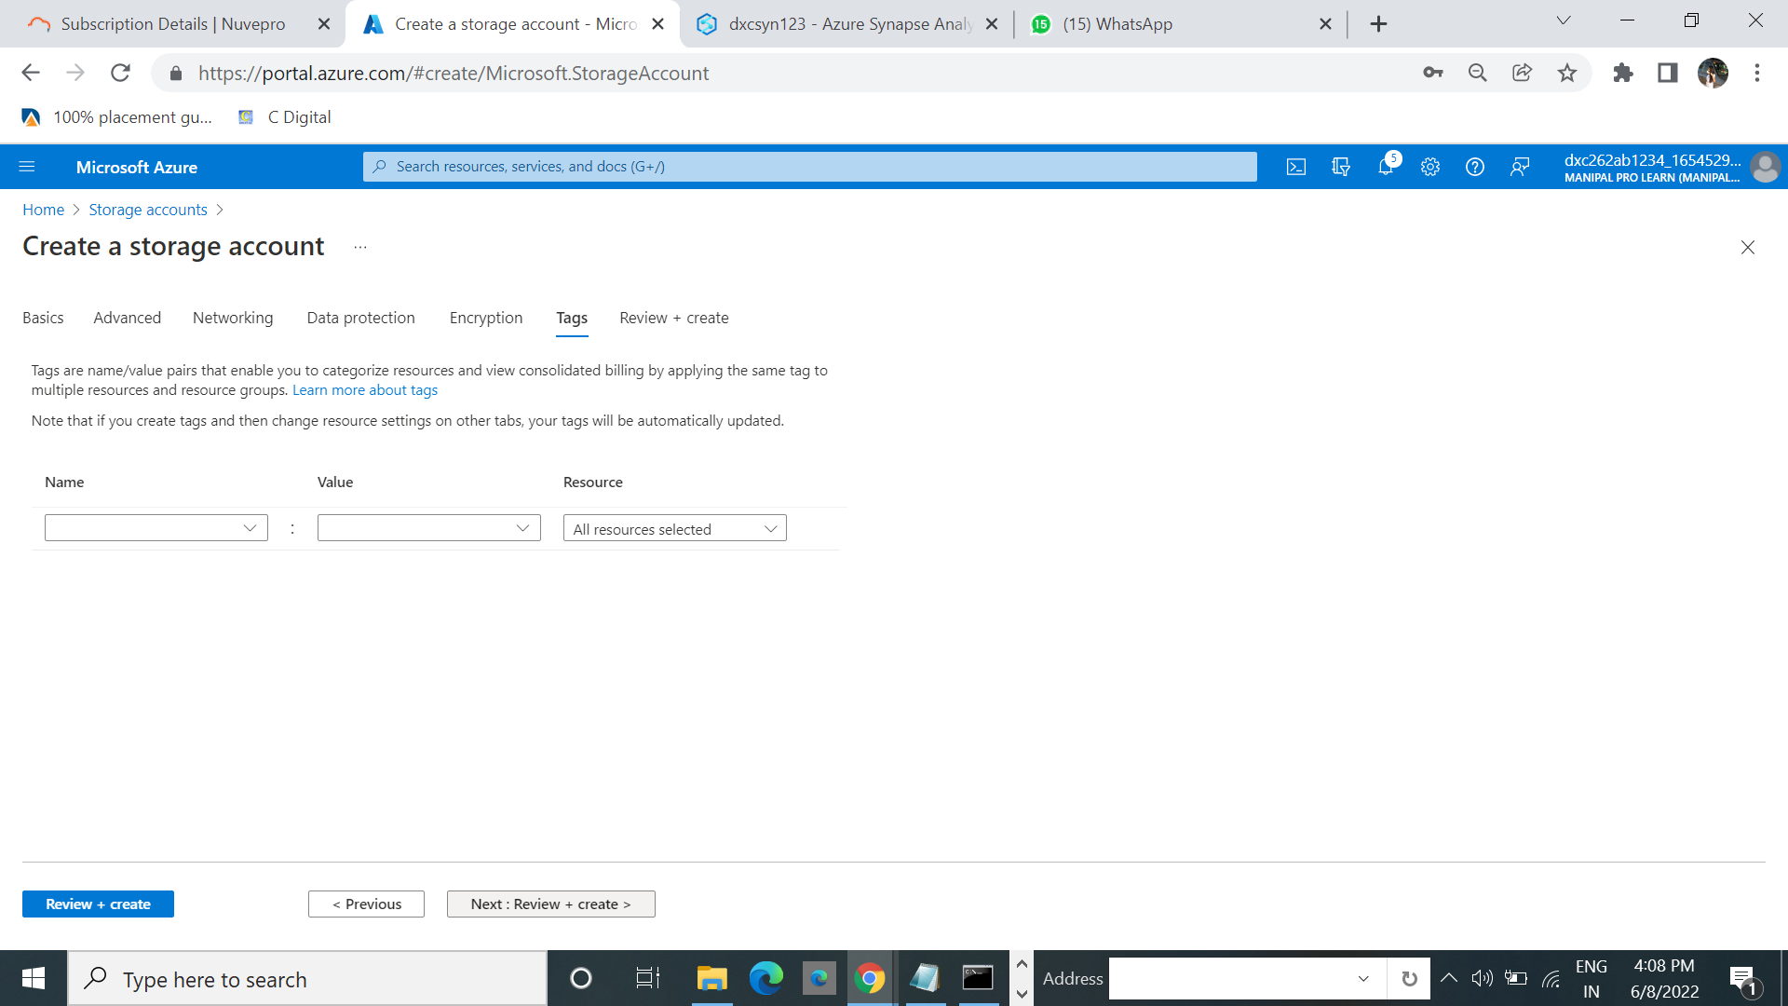

6.When you navigate to the **Review + create** tab, Azure runs validation on the storage account settings that you have chosen.

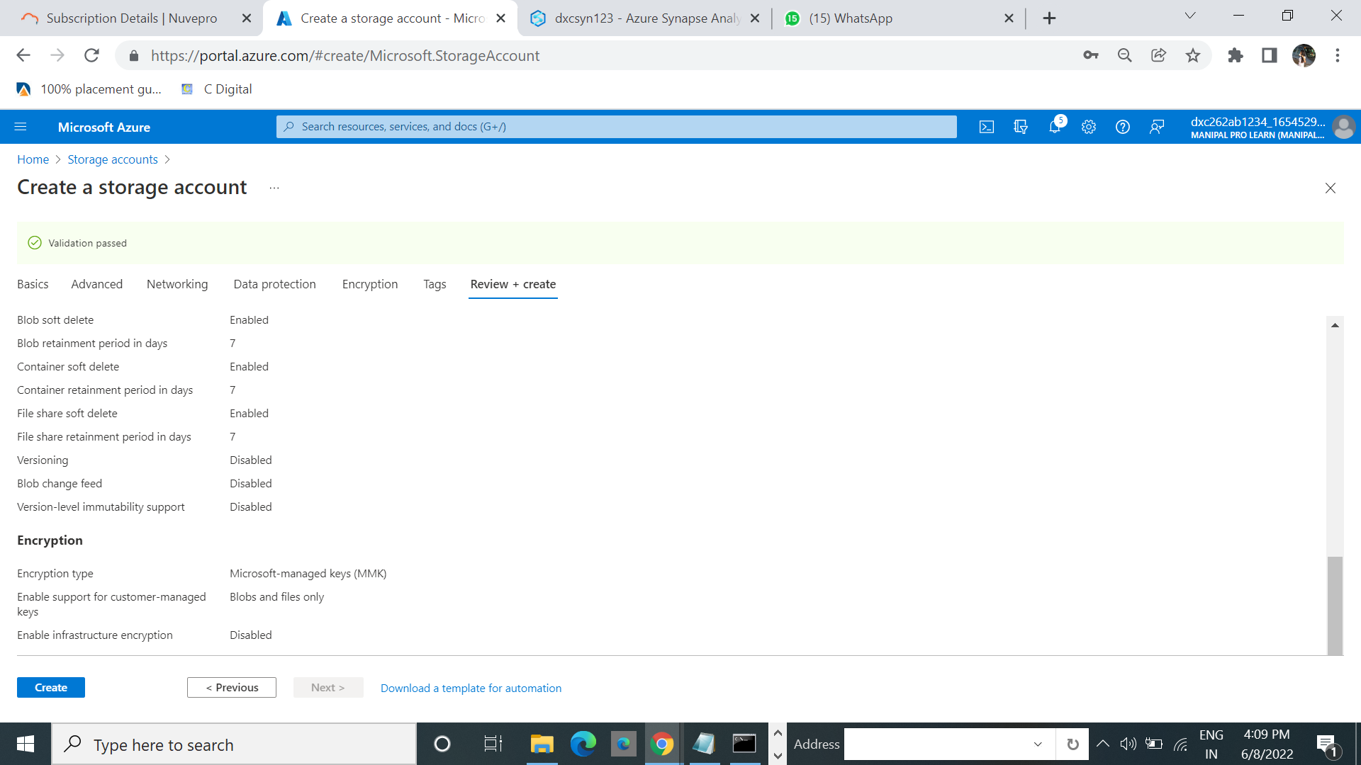

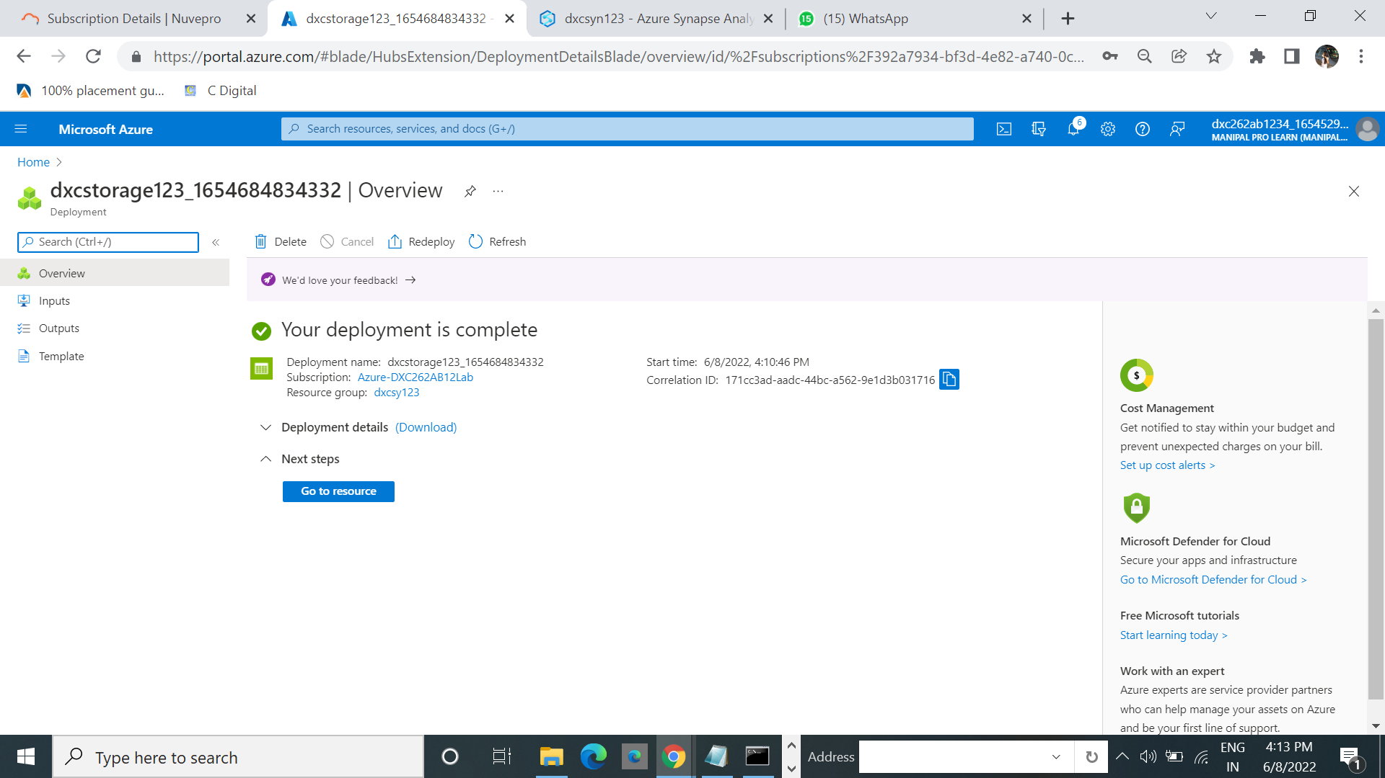

**2.Explain the steps with screenshots how to create virtual machines & how to connect from**

**(i) Local Computer – cmd method**

**(ii)Using Azure cloud shell**

**(iii)Also using Azure Bastion ?**

**Local computer –cmd method :**

1.First select the virtual machines from the list.

2.Then click on that .select the create .

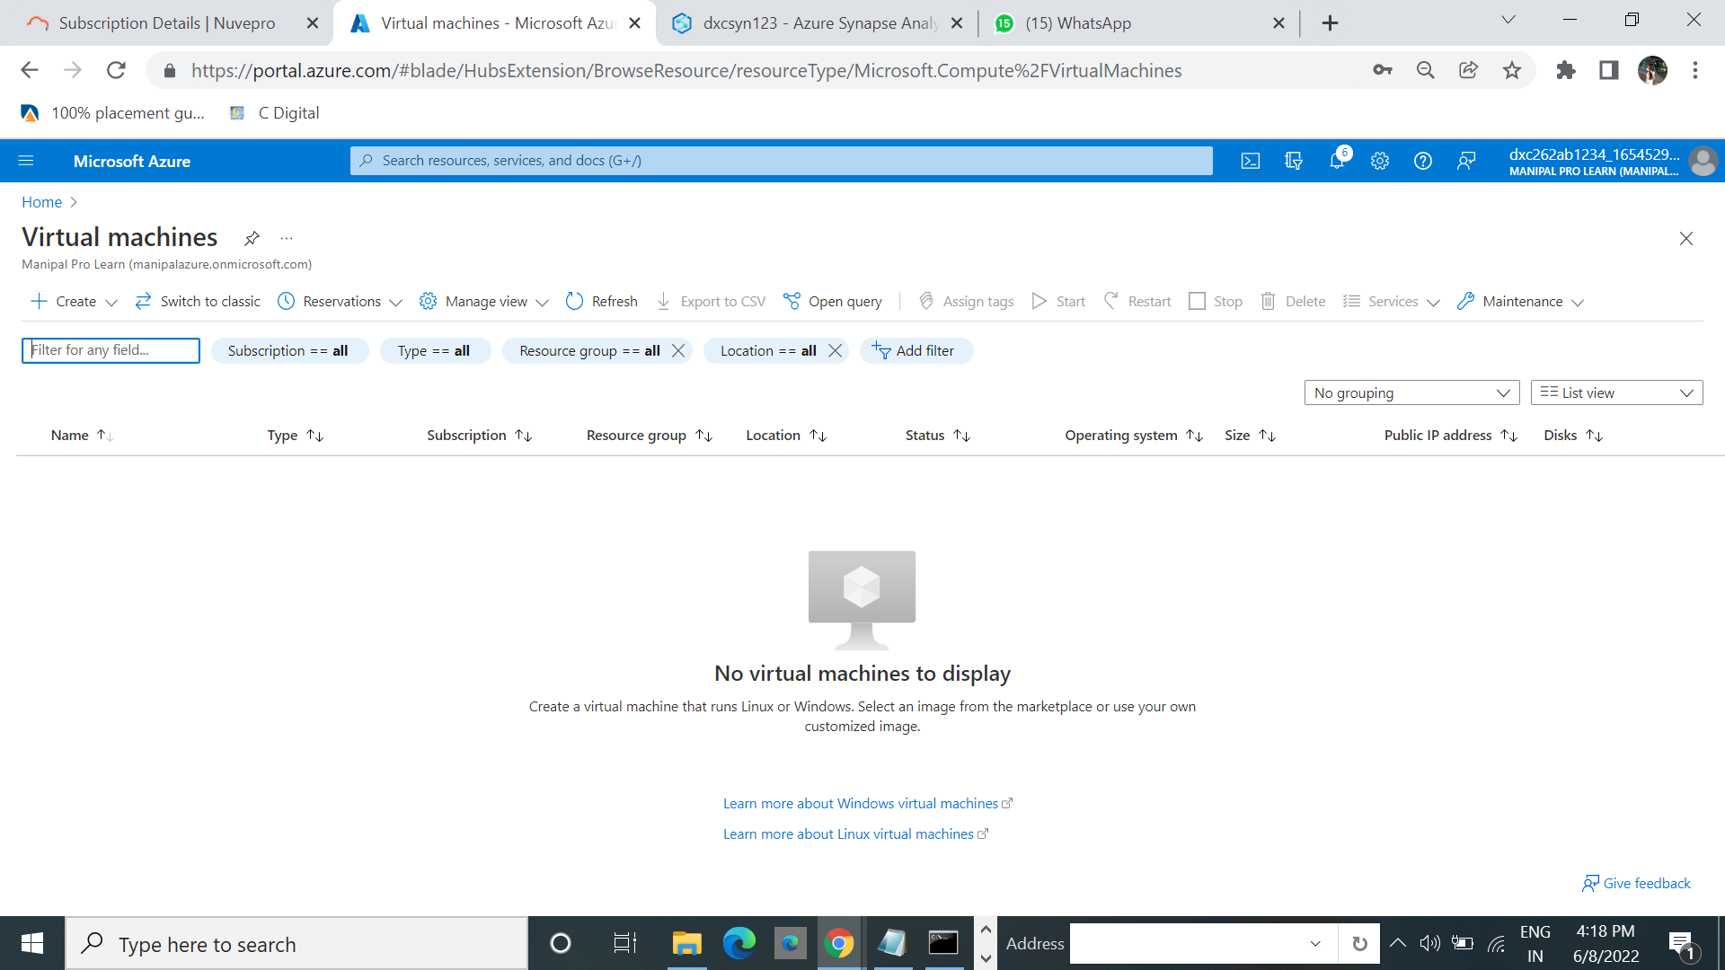

3.In the drop down select Azure virtual machines.

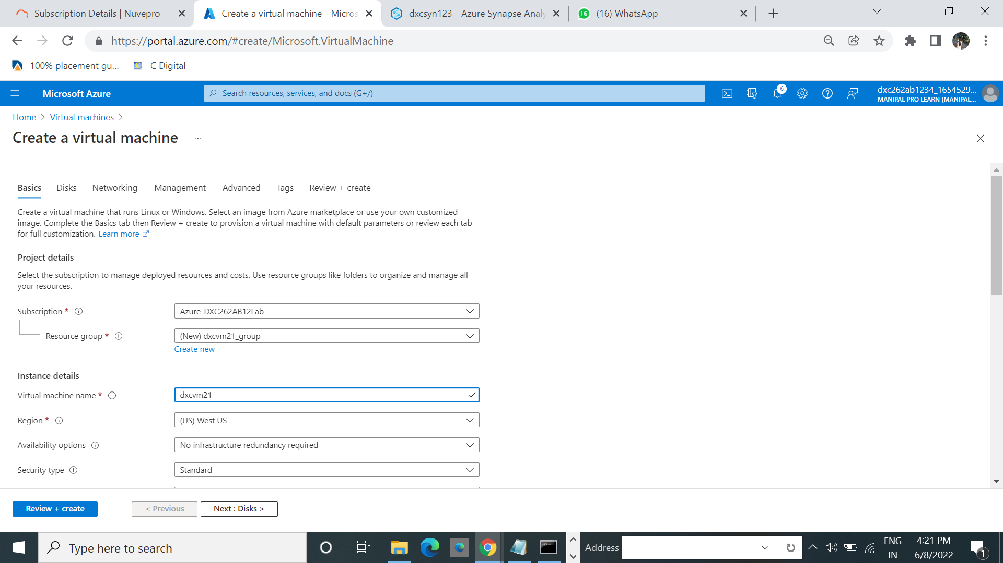

4.Click on review +create.

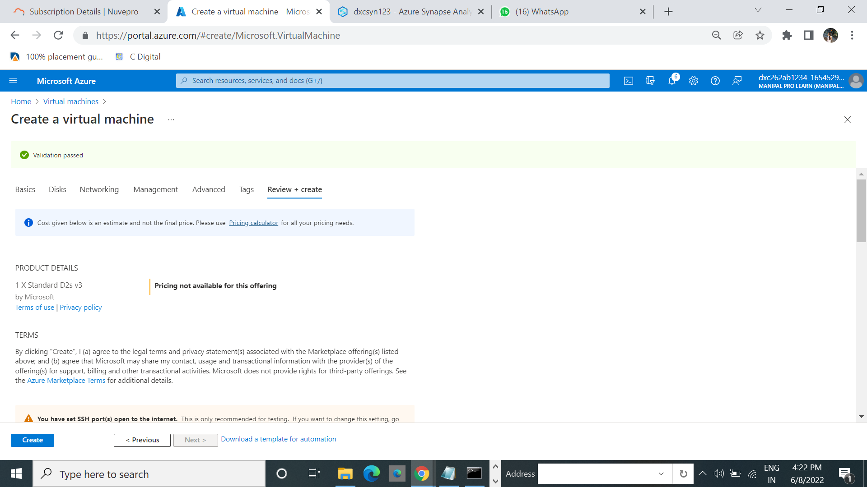

5.Click create then click on download private key and create resouruce.

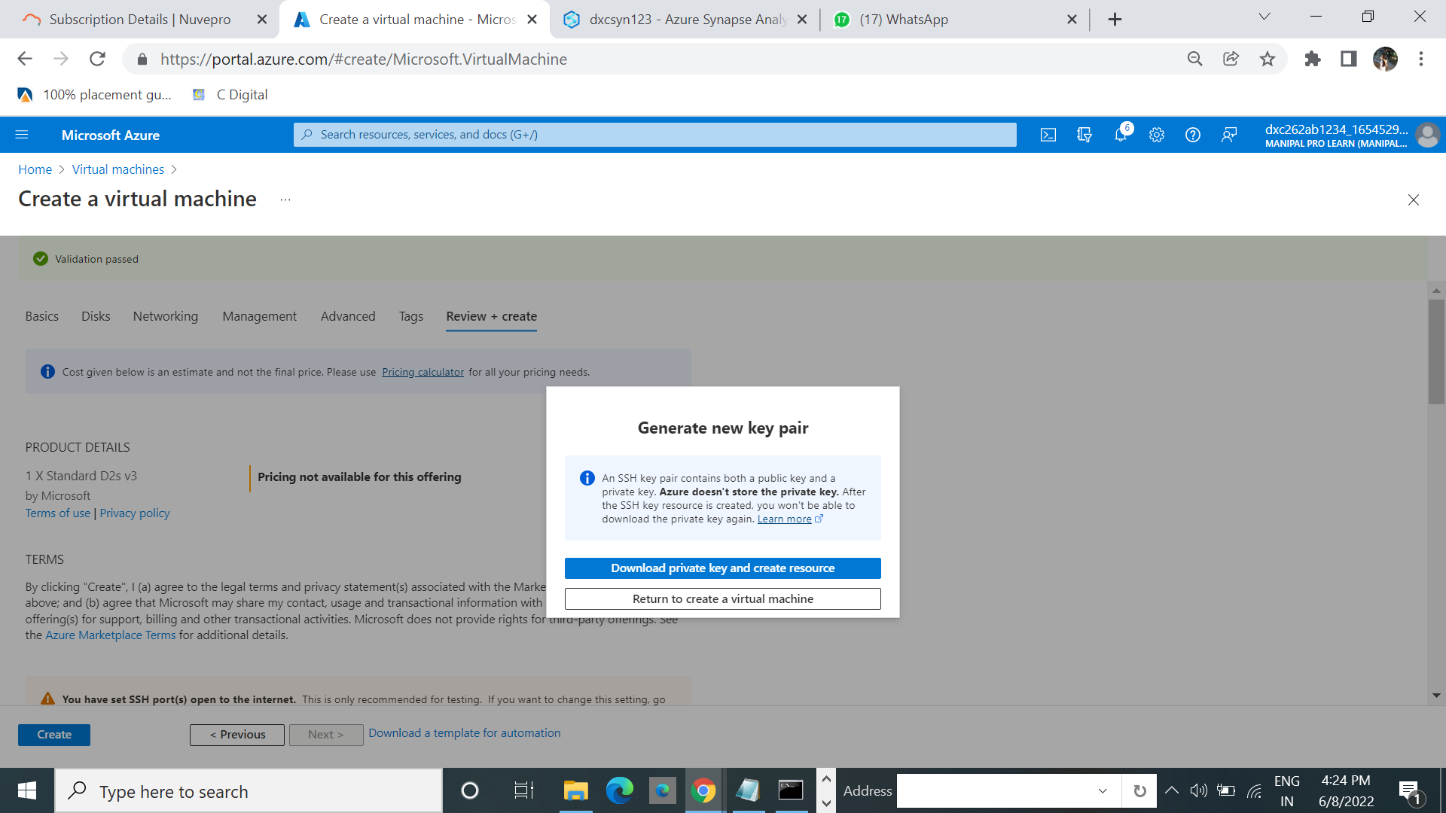

6.Click on Go to resource.

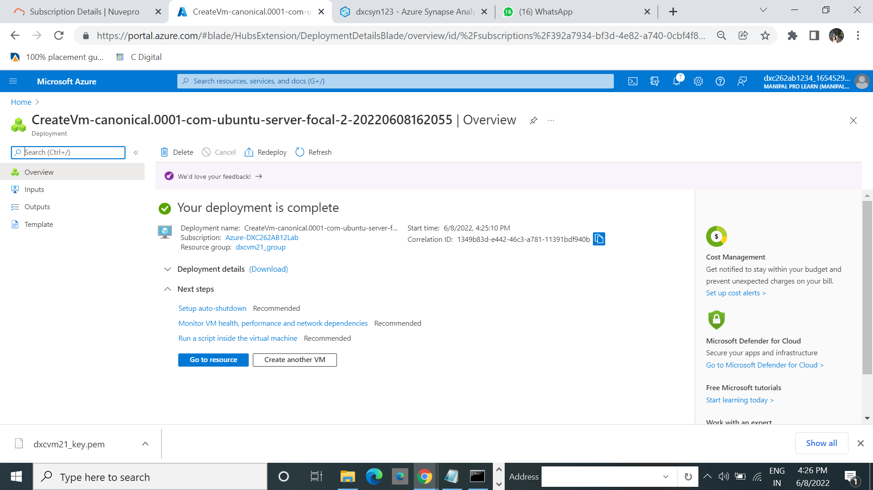

7.Click on connect and select SSH.

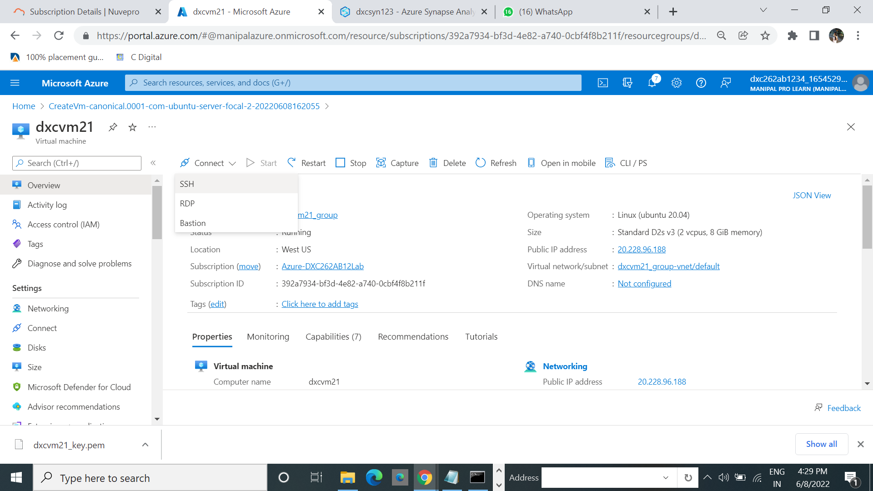

8.Copy the run time example command and paste it on notepad.

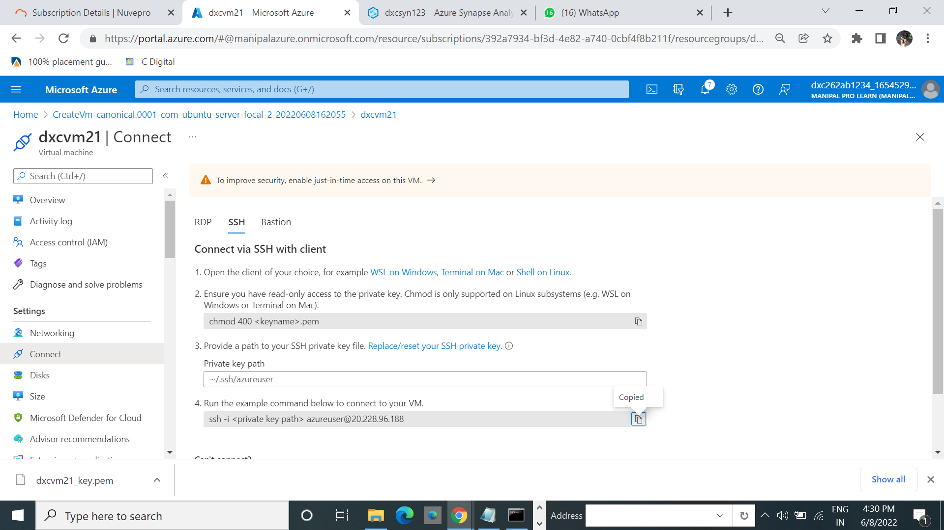

9.And then copy the address of private key where it was dowlaoded.

10. Run the cmd with the address.

**(ii) Using Azure cloud shell**

1.If the cmd does not work properly then we can use cloud shell.

2.Go to previous page and click on CL/PL.

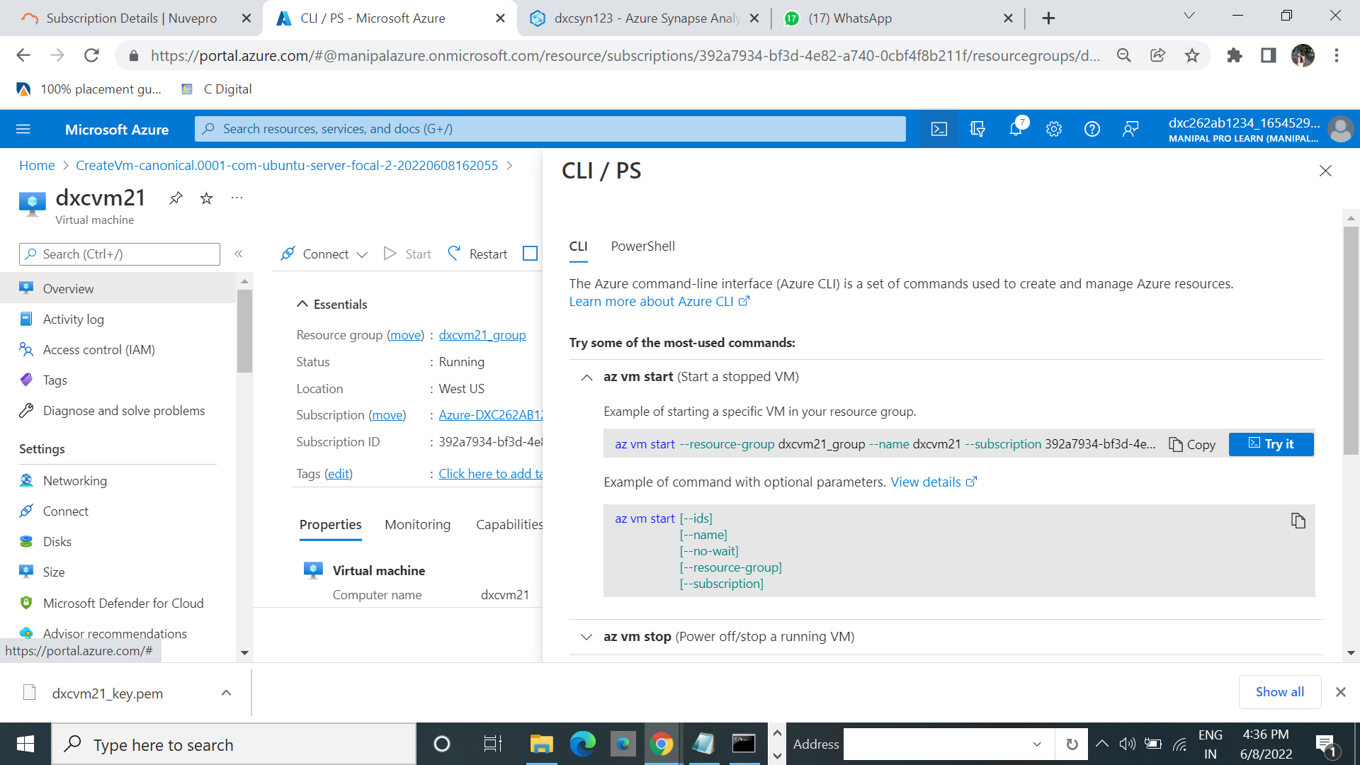

3.Click on the powershell ,which right to the search bar.

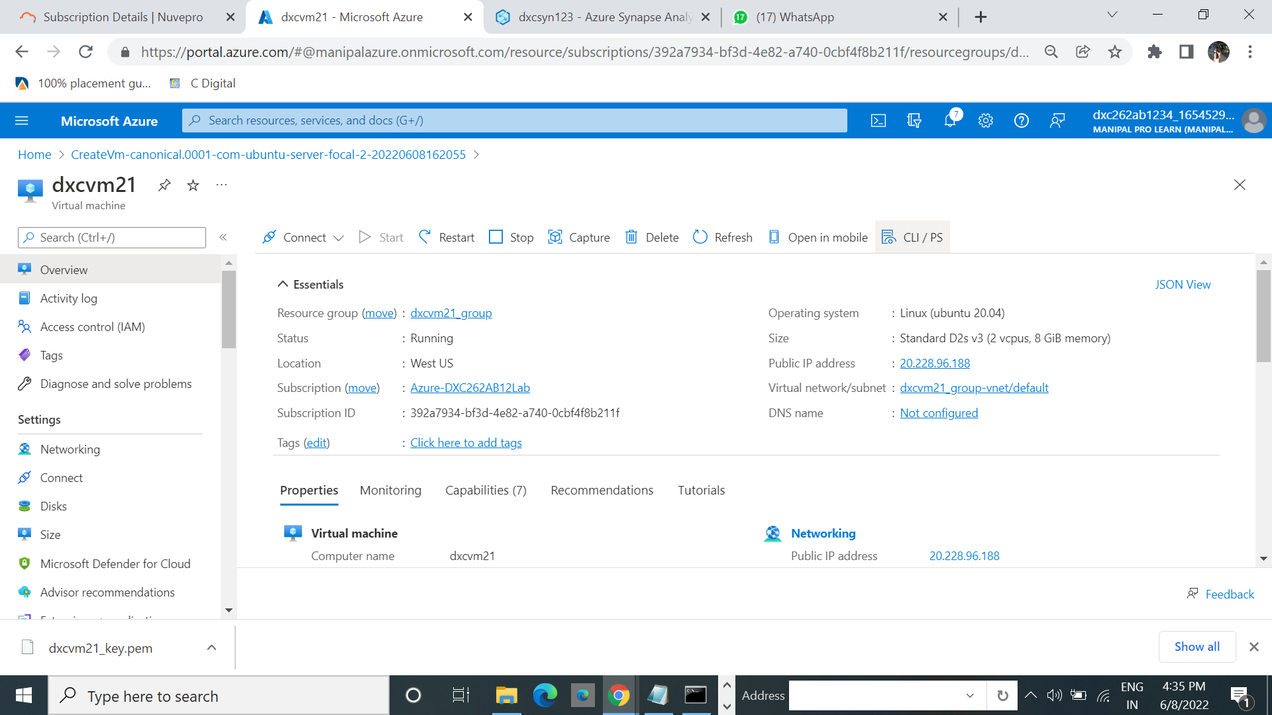

4.Run the command $ ls –lrt

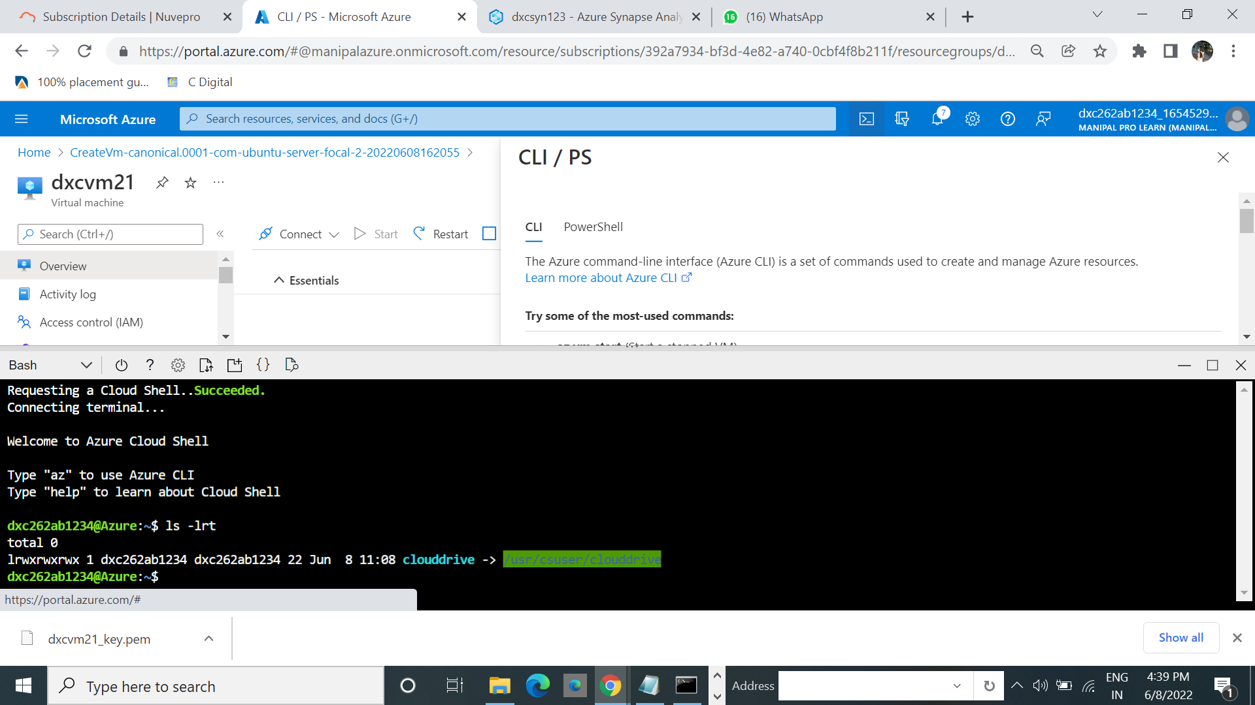

5.After that run the start command which is present in cl/pl

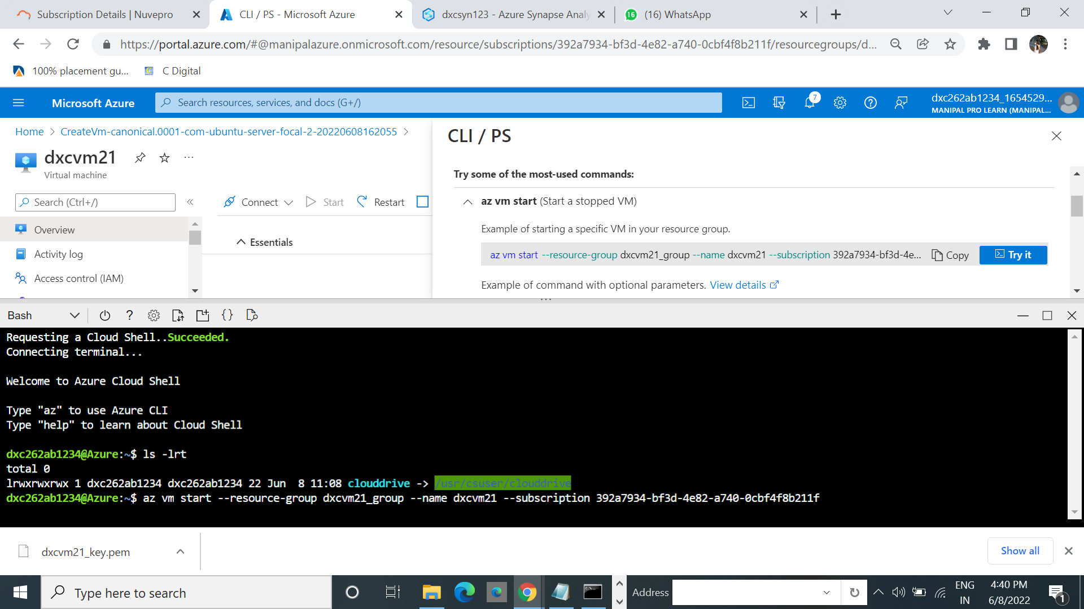

6.Run the show command

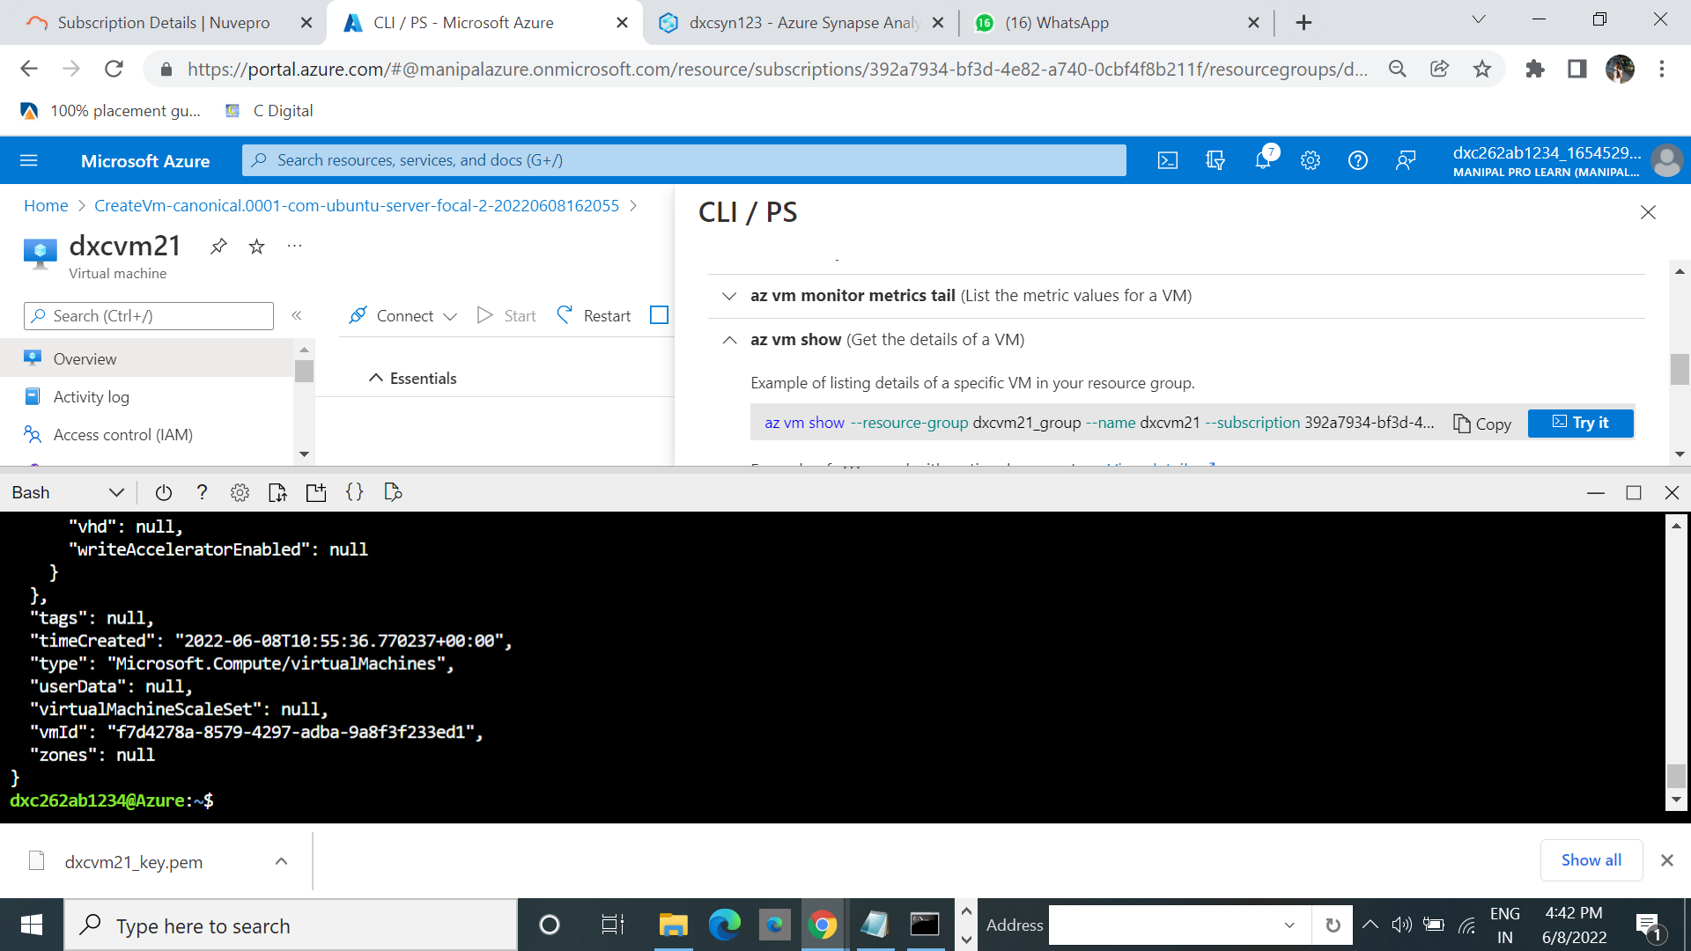

7.It successfully connected.

**(iii)Using Bastion**

1.While we are connecting with the cmd .We used connect and select the SHH

2.After that select bastion

3. Click on use bastion

4.Select the create Azure Bastion usinf defaults.

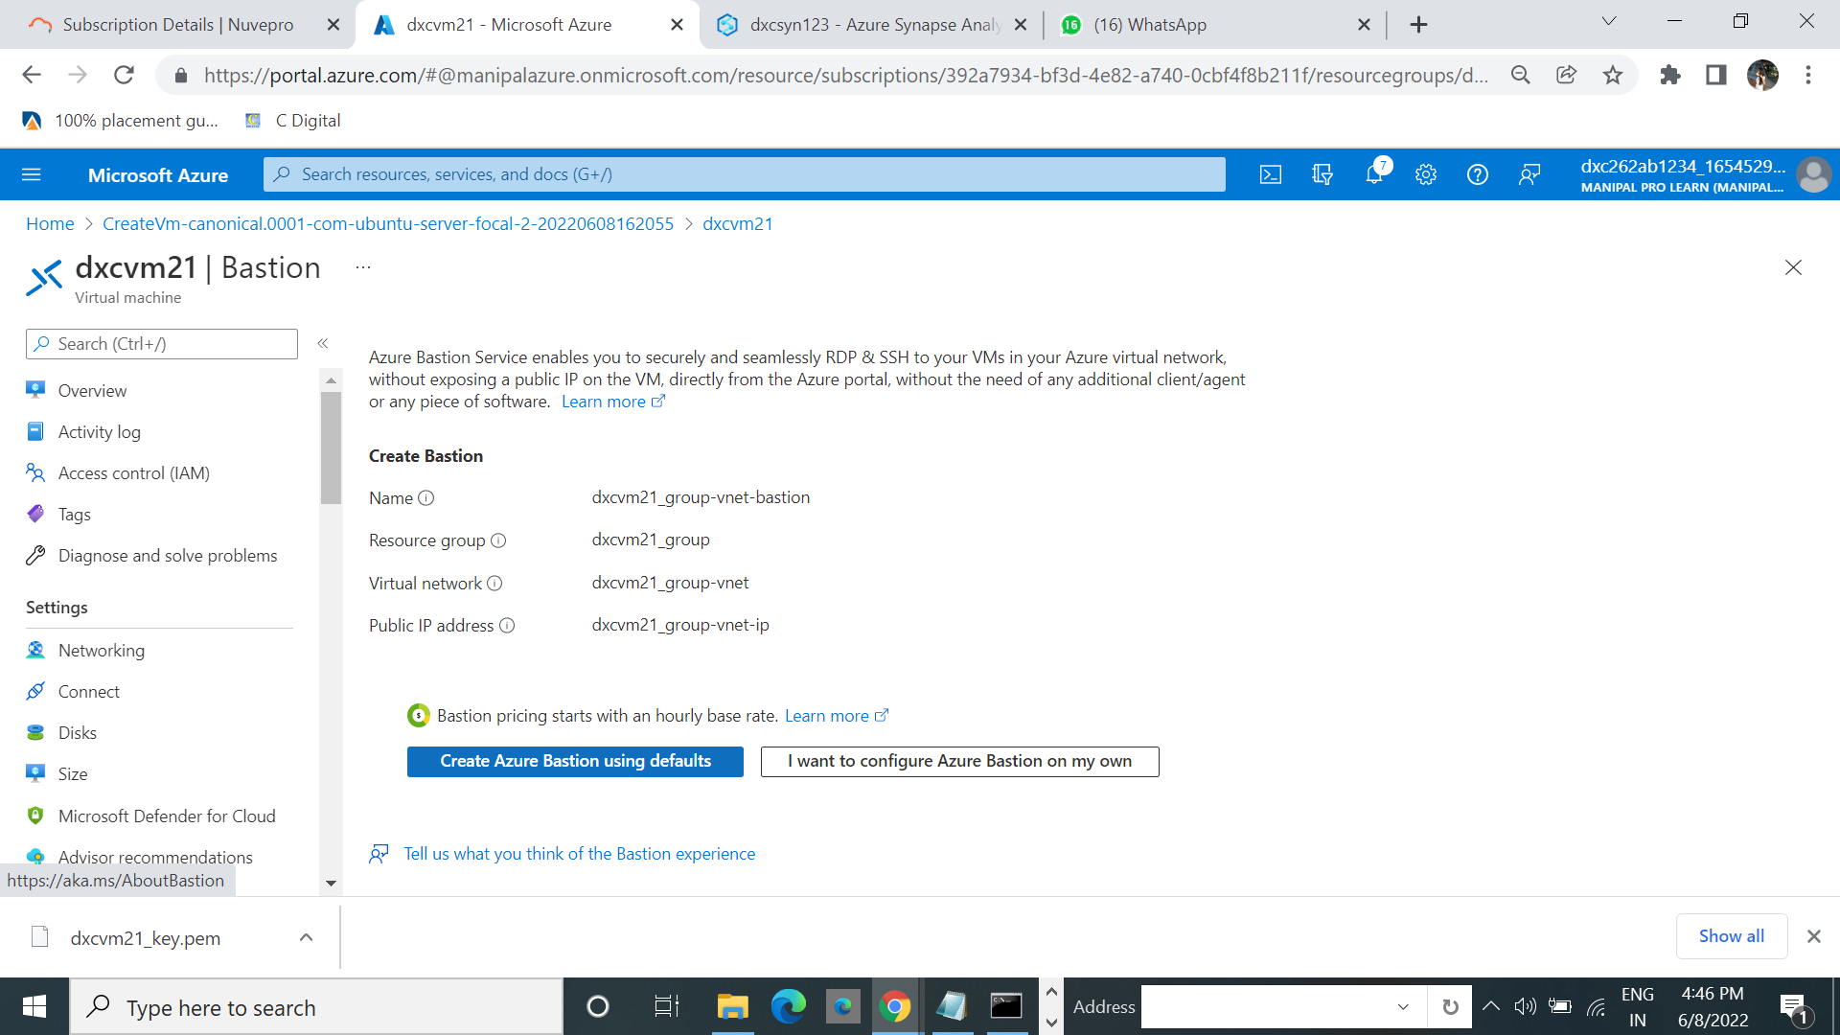

5.It starts creating.

6.After we get notification that the bastion is created successfully.

3.**Explain the steps with screenshots how to create a data factory?**

1.From home page select the Data factory.

2.Click on create.

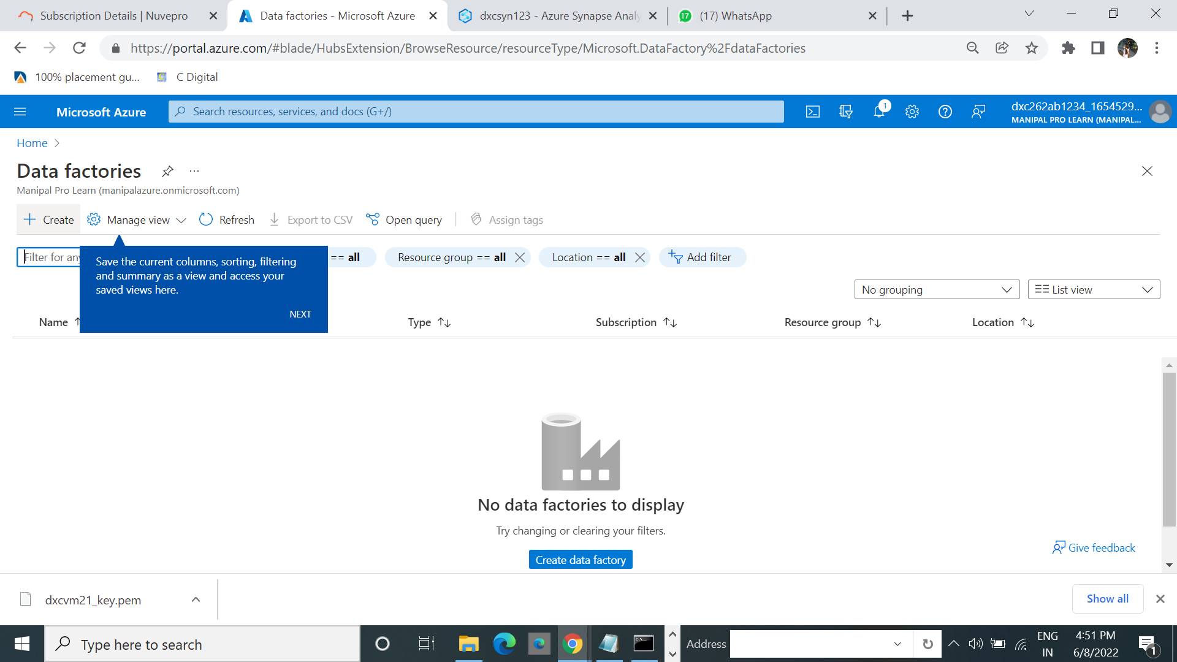

3.Click on get confg

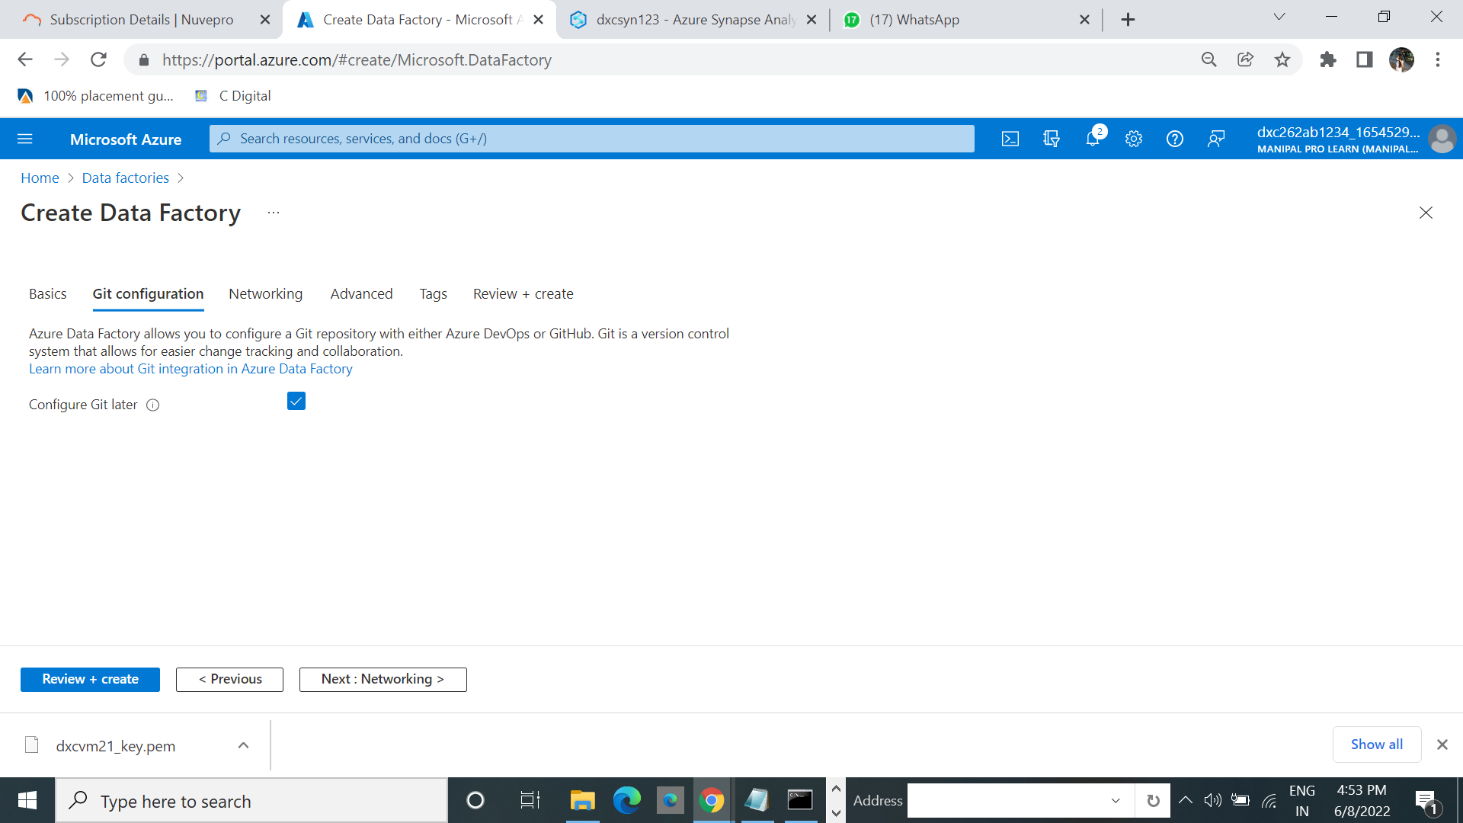

4.Click on review+create. And click on create.

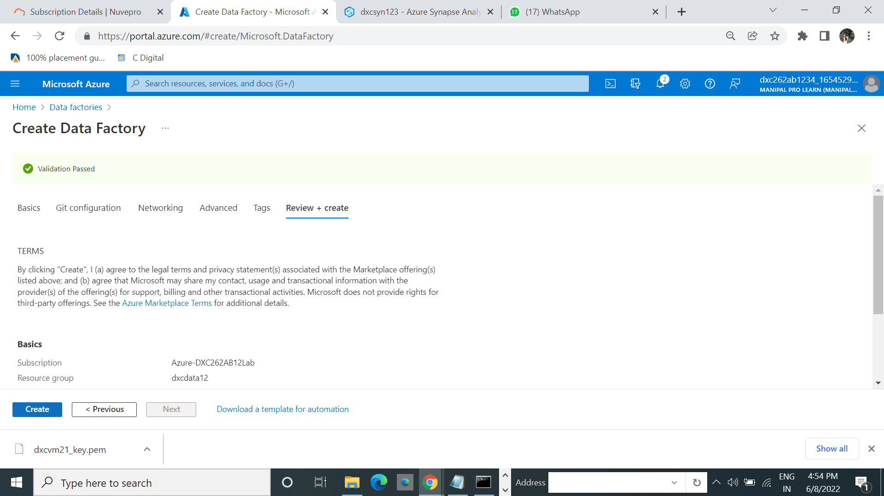

6. After completion of Deployment Click on Go to resources.

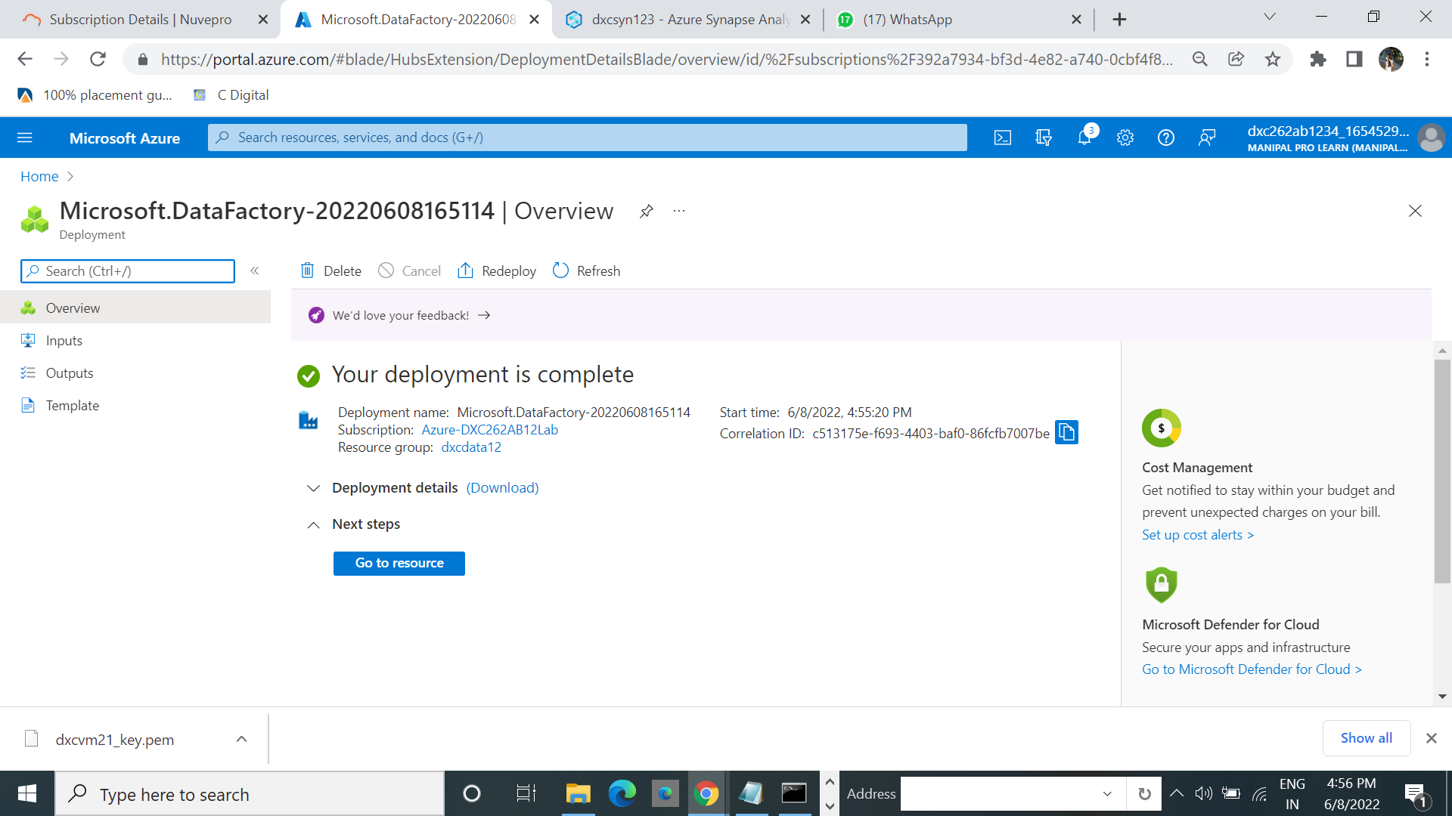

7. Click on Azure data Studio.

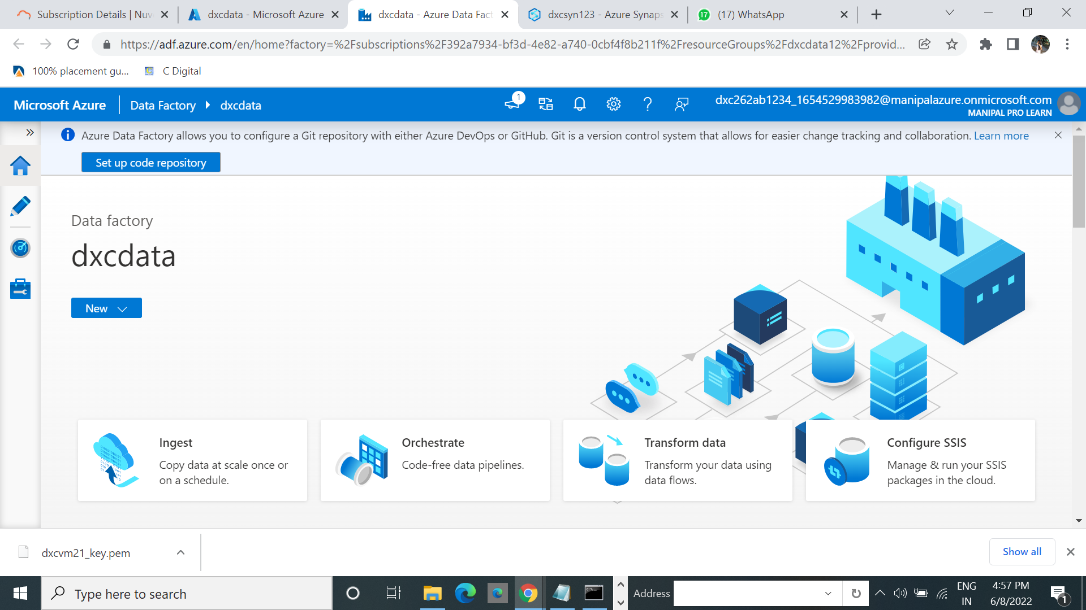

**4.Explain with screenshots how to copy data from source blob to destination blob ?**

As we created the data factory keep it a side and create a storage account in that create 2 containers datasource and datadestination

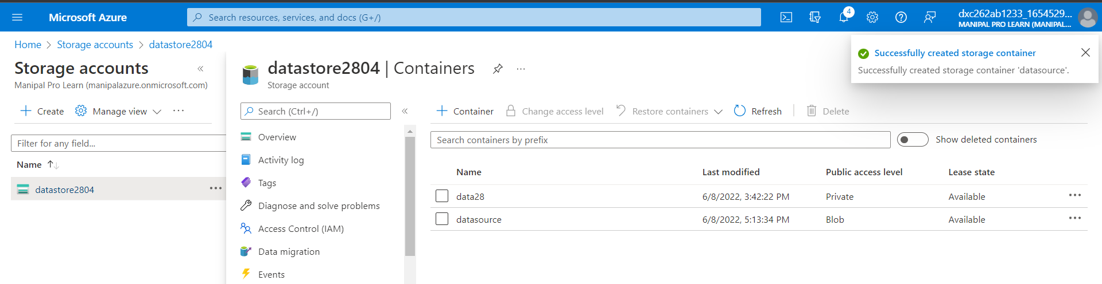

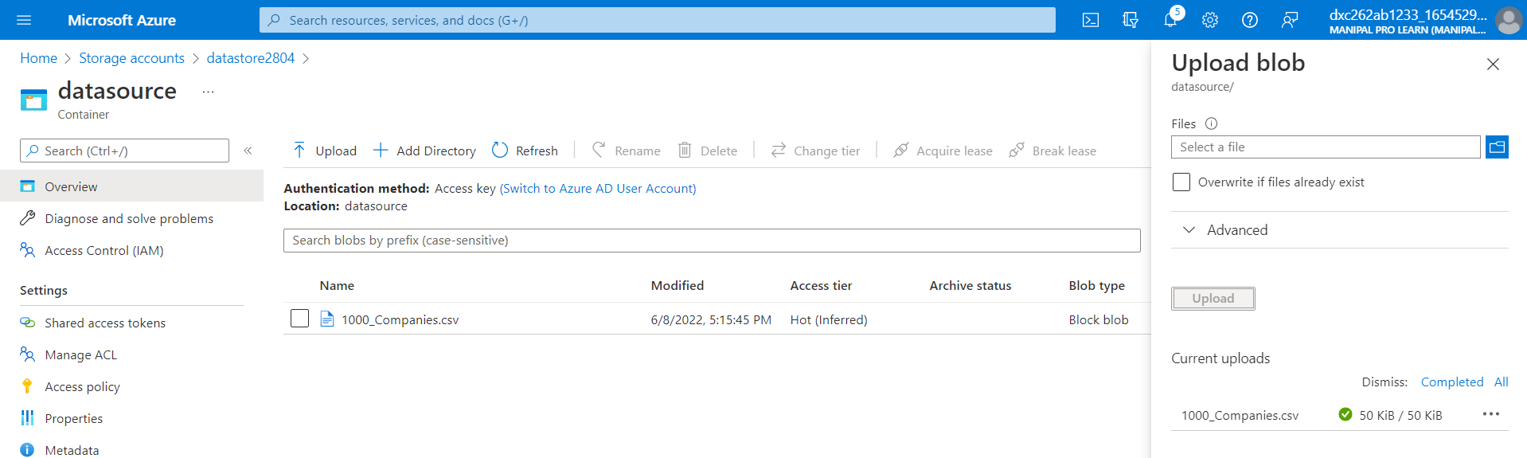

In datasource upload a file of any type but don’t upload any file in the datadestination

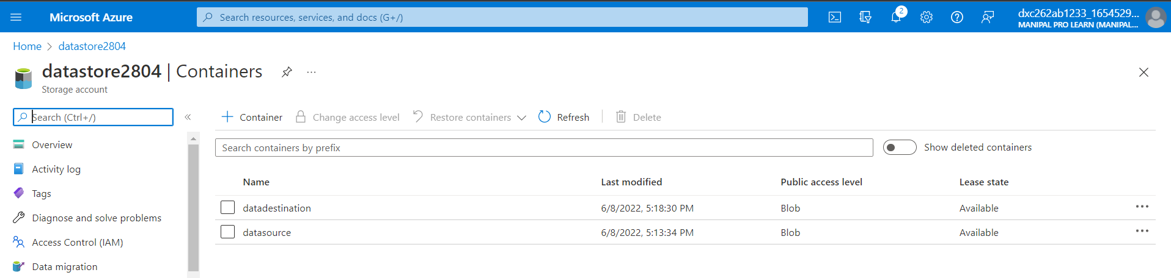

come to data factory and click on ingest option

-click on build in copy task and next

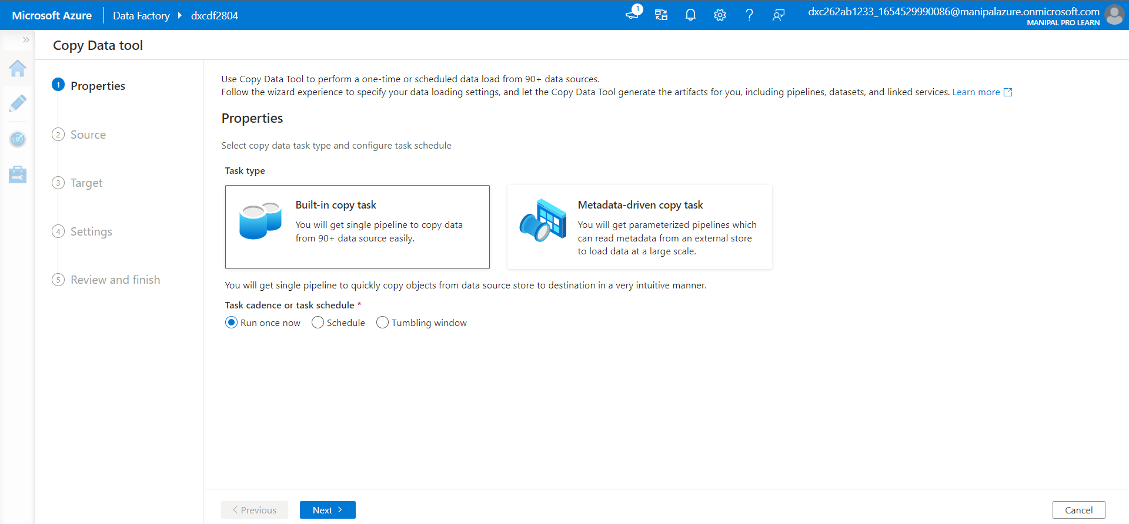

source type is Azure blob storage

-connection new description:AazureblobStorage1 and create

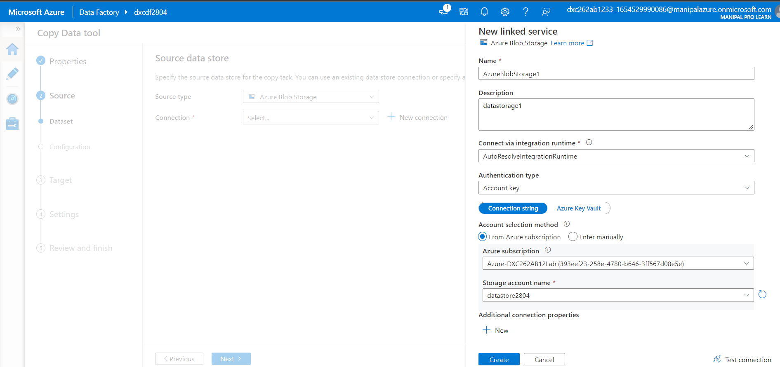

we will come to Source data store

in file or folder browse and select datasource/1000_companies data and ok

-next

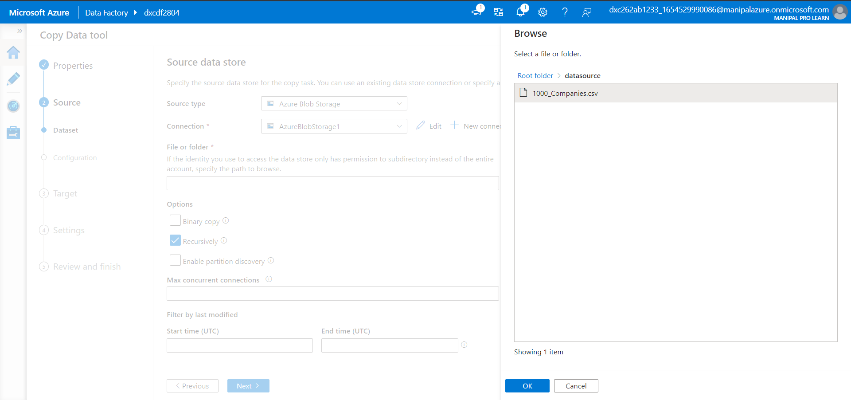

Same for destination as well

destination data store

select the destinationblob1

in file or folder browse and select datadestination and ok

-next we will go to File format setting every thing is default and next

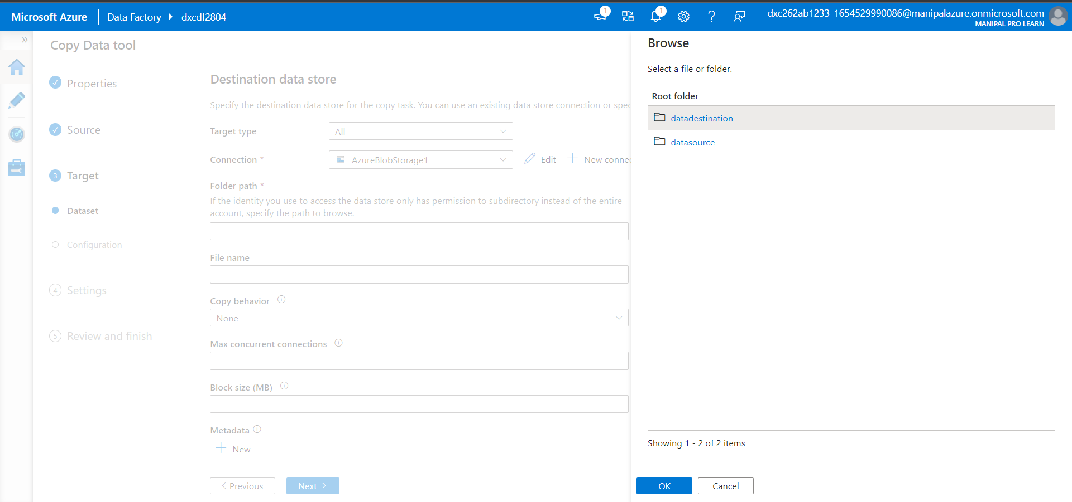

-next settings next, summary next so it will copy my files to datasource to datadestination

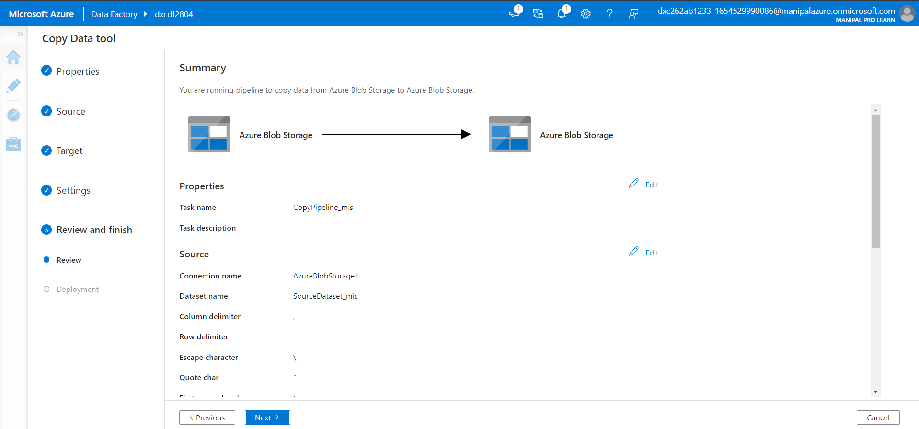

-validation and finish

we have to go to dxcstorage2804 in that

-we need to open the datadestination the file is copied in it

-this is happened because of the data factory

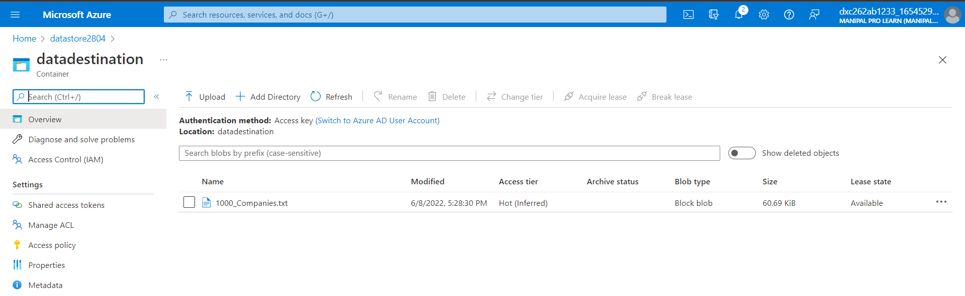



**5.Explain steps with screenshots how to create a virtual network in Azure ?**

1.Search for the virtual networks .Click on virtual networks.

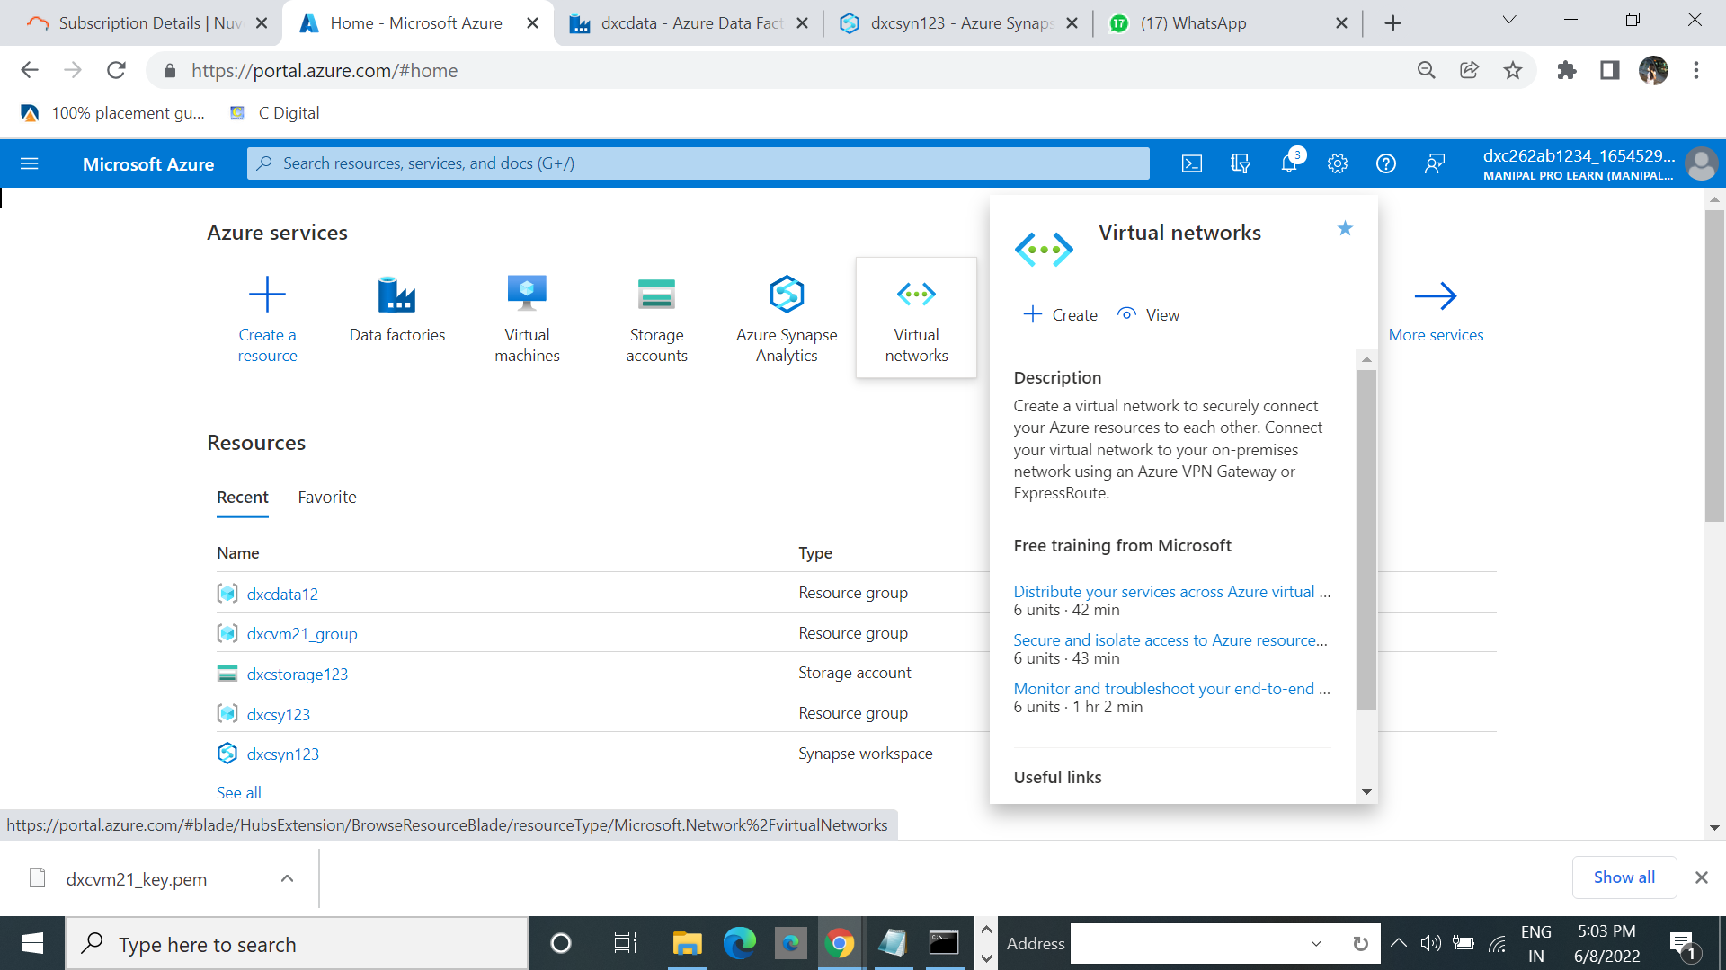

2,Click on create.

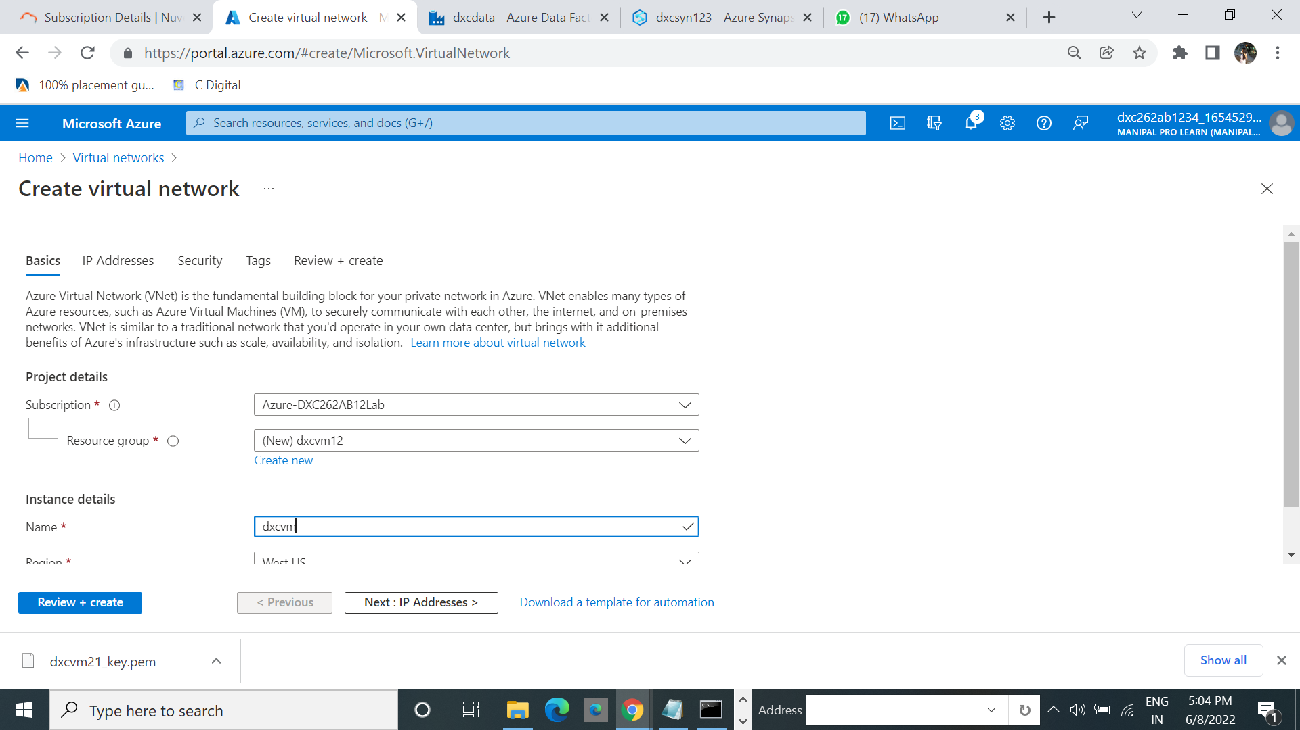

3.Click on review+create.

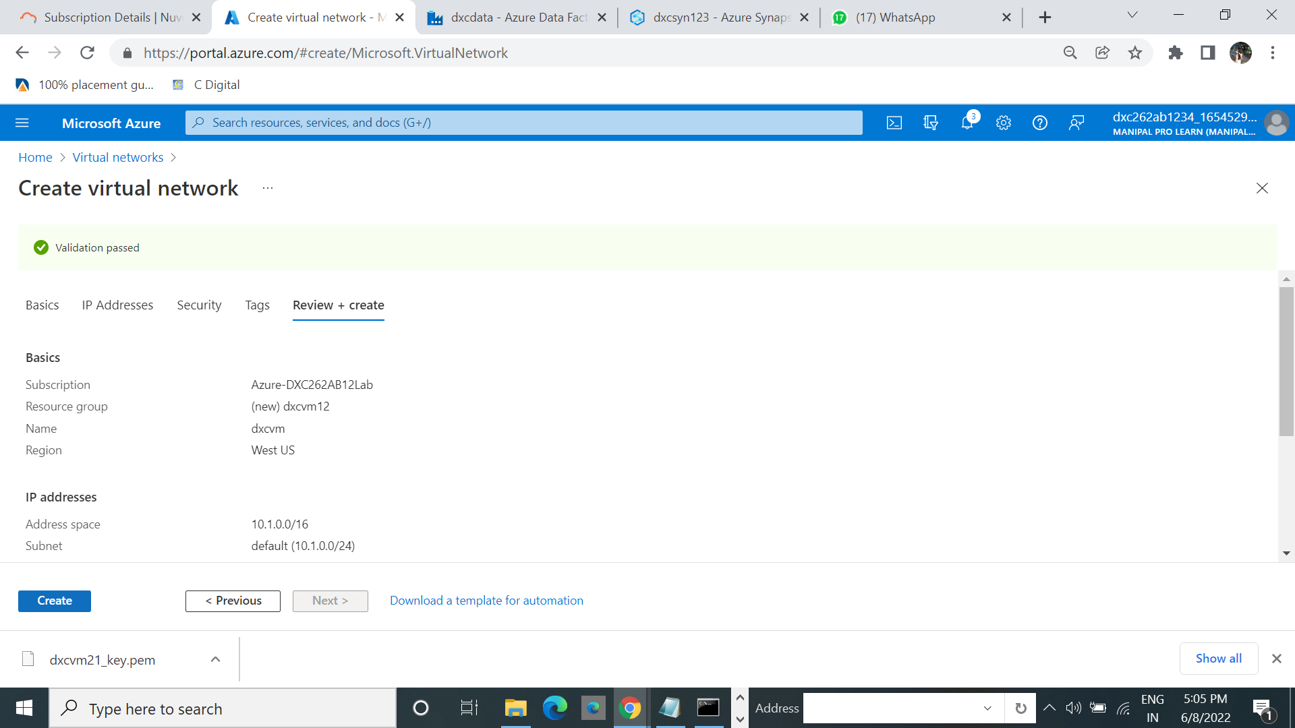

4.Click on create.Then the Process of deployment will start.

Deployment completion click on Go to resource.



5.The virtual network is created.

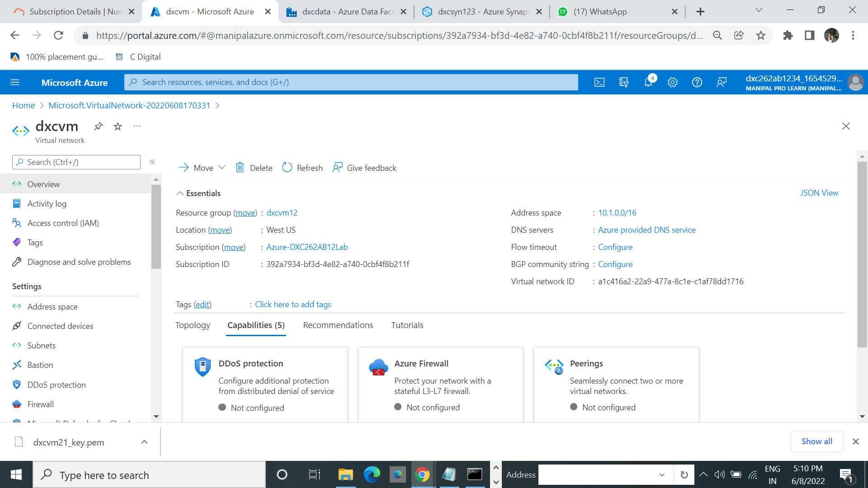

**6.Explain the steps with screenshots how to create a Azure synapse analytics ?**

1.Search for th Azure synapse analytics.Select the synapse analytics.

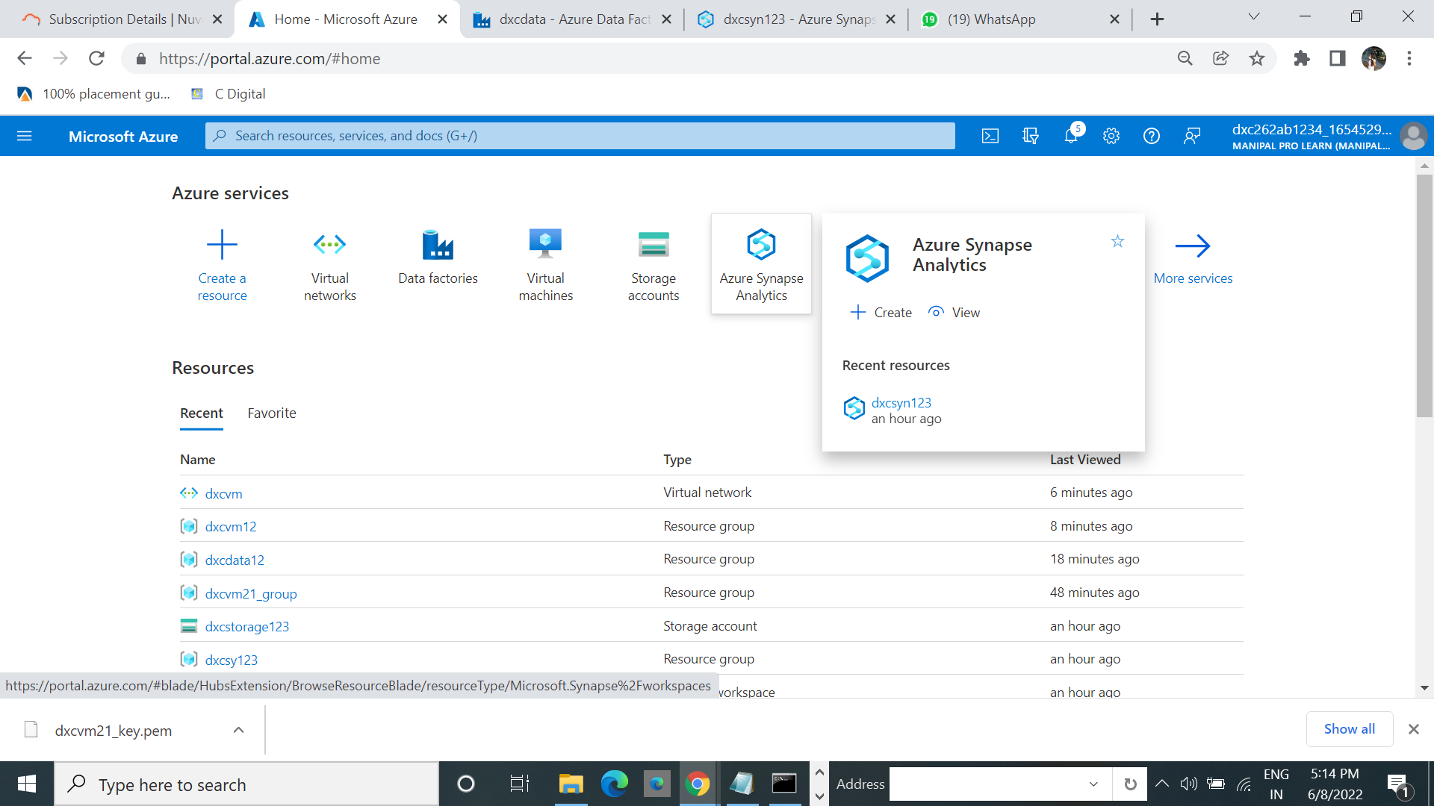

2.Click on create. 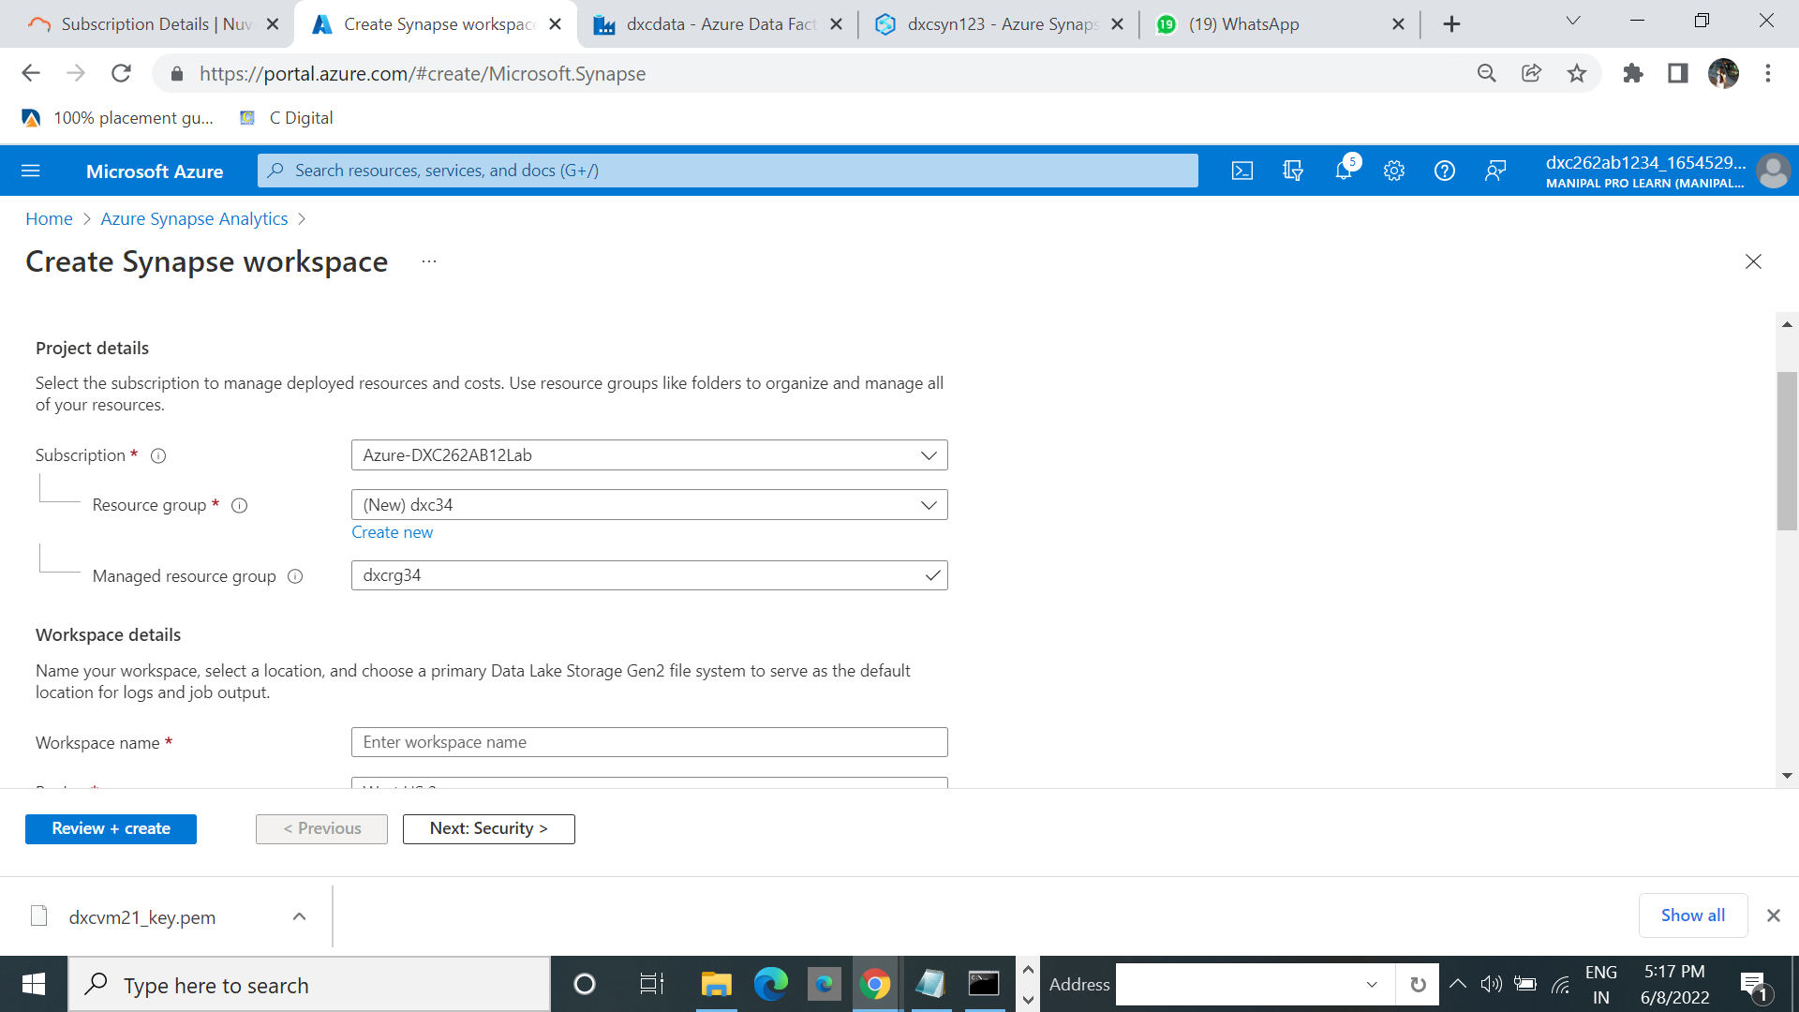

3.Click on next security.create useid and password.

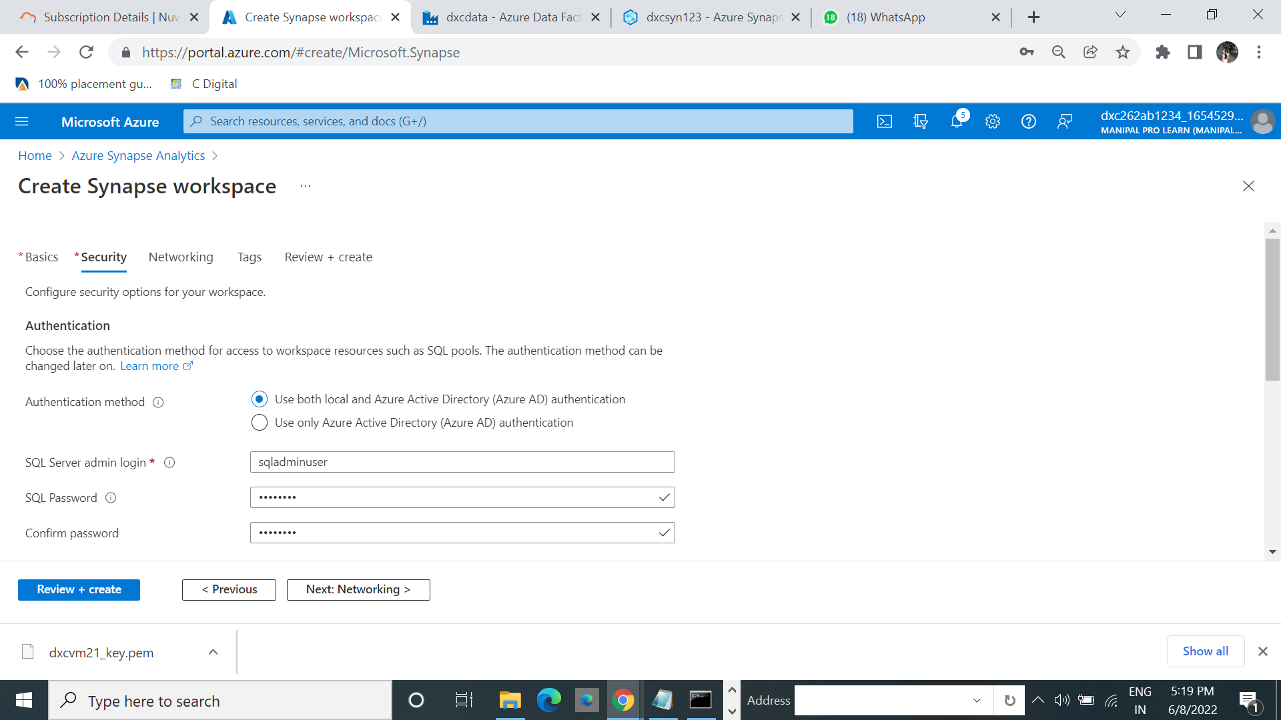

4.Click on review+create.

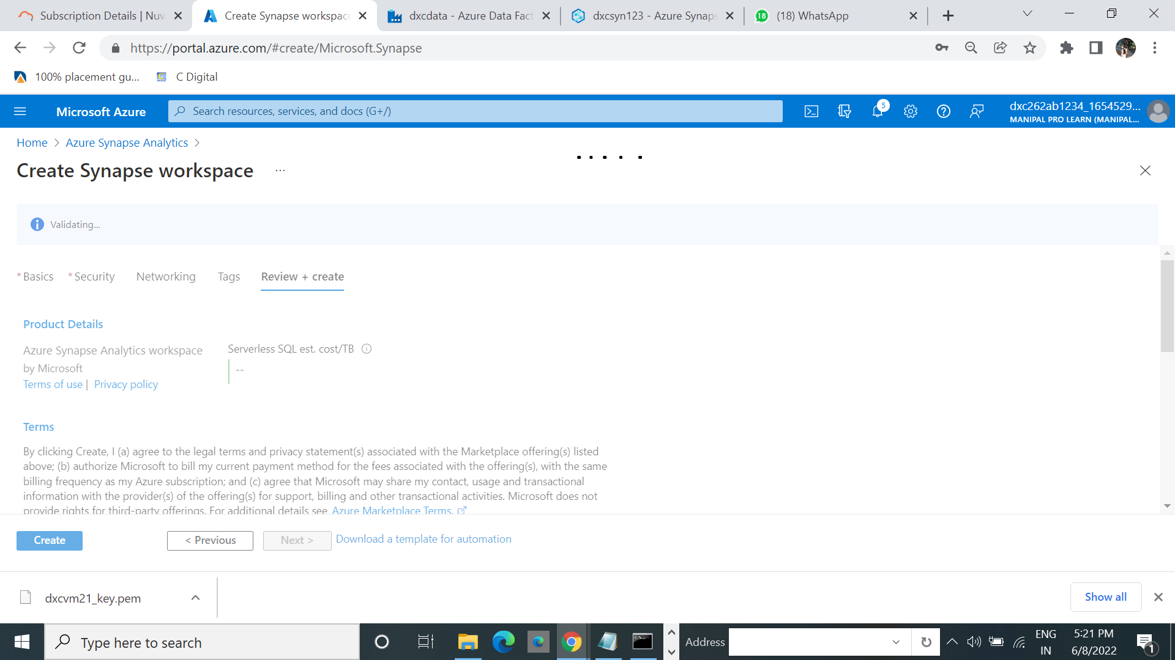

5.Click on go to resources.

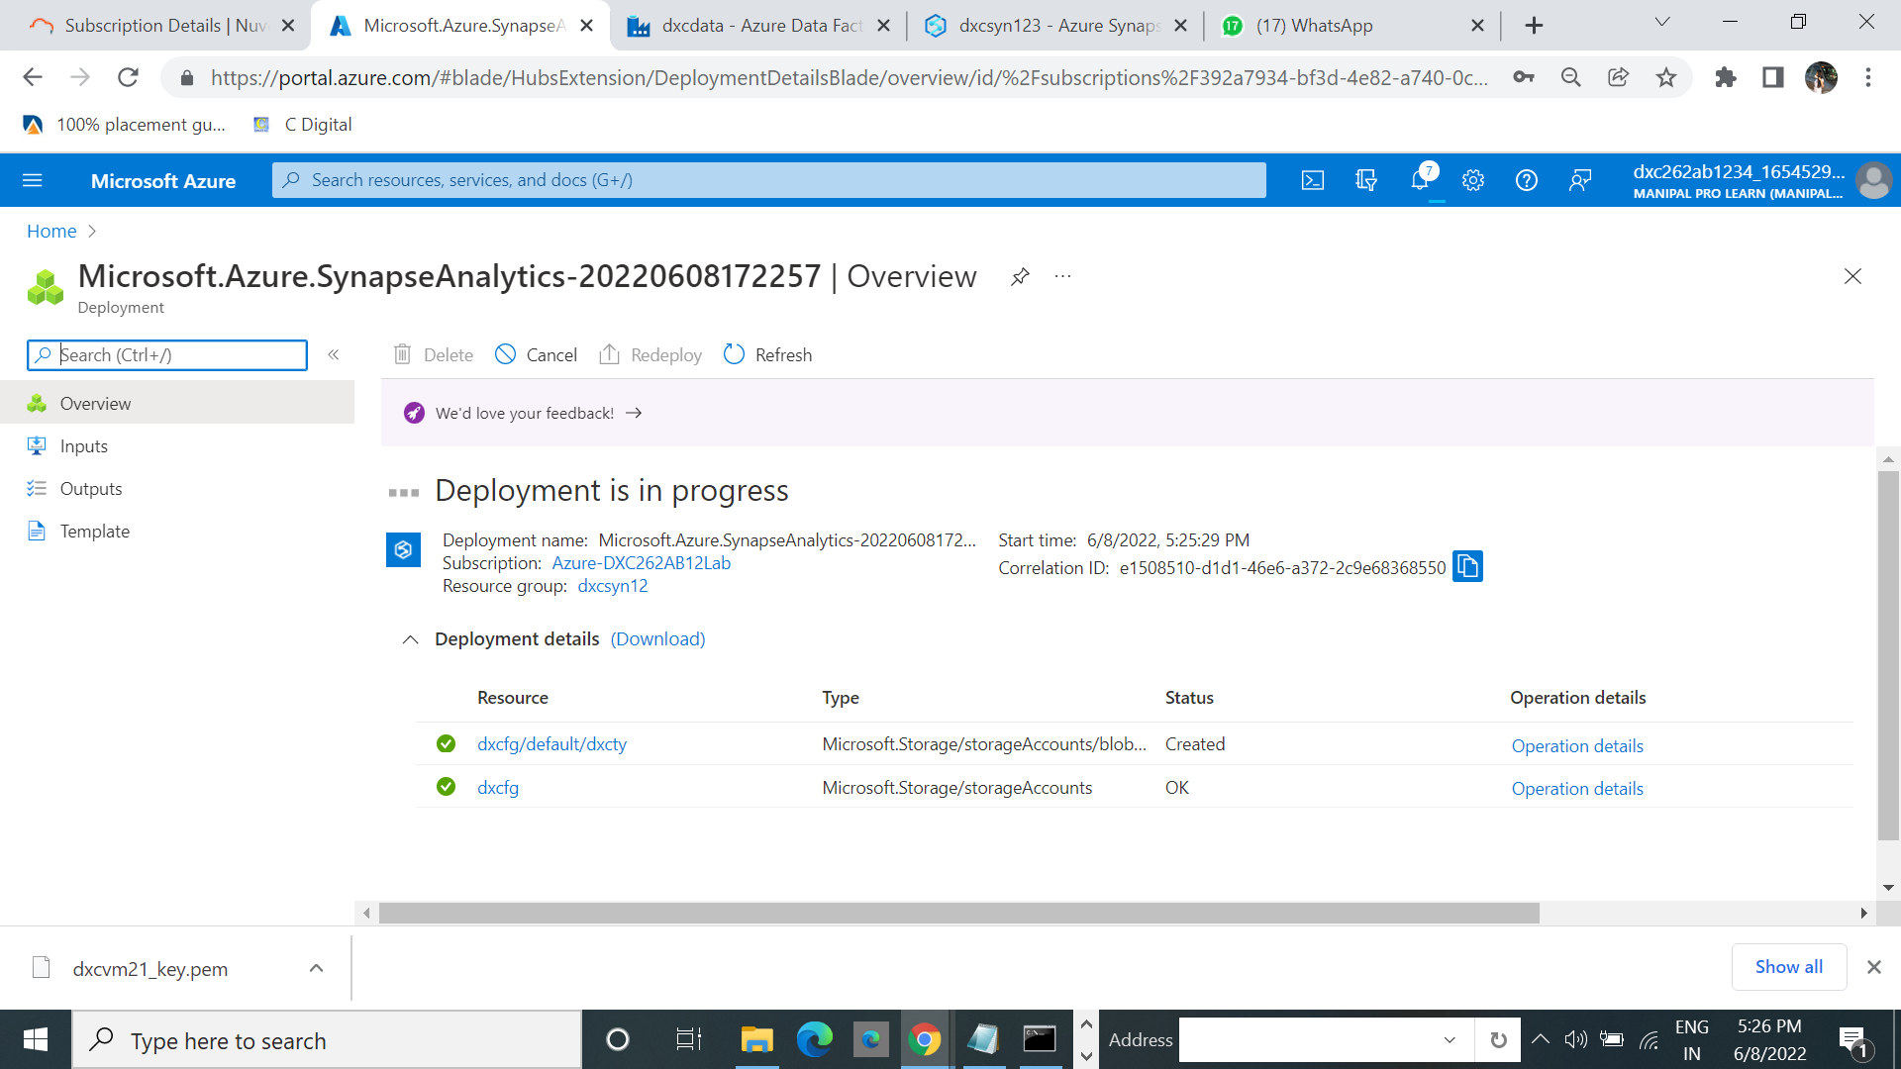

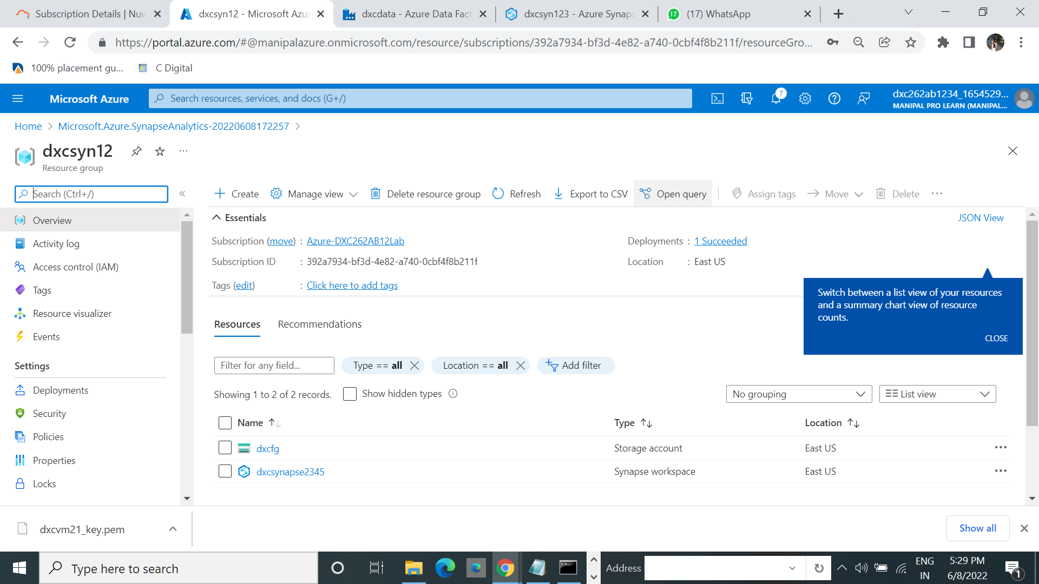

**7.Explain steps with screenshots how to create Azure storage account ?**

1.Search for the Azure storage account. Select the storage account and click on create.

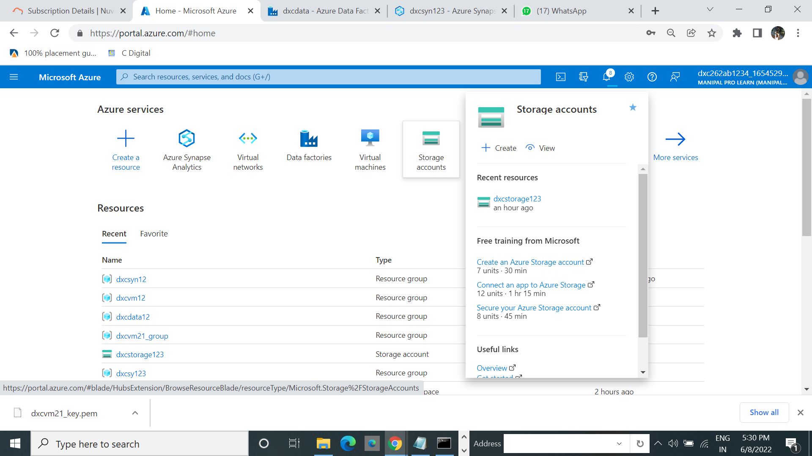

2.Click on create.

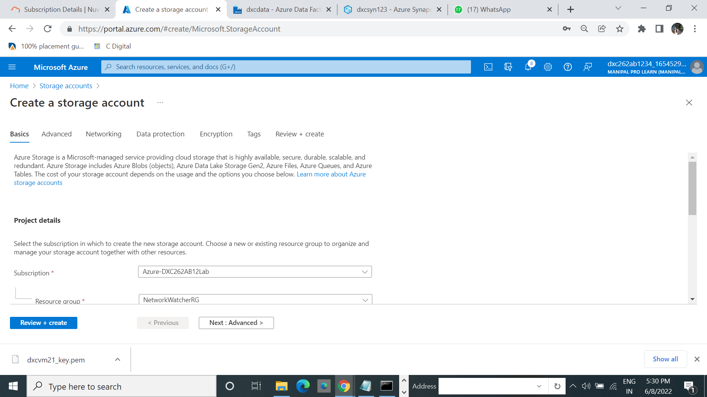

3.Fill the resource group and work group and click on review_create.

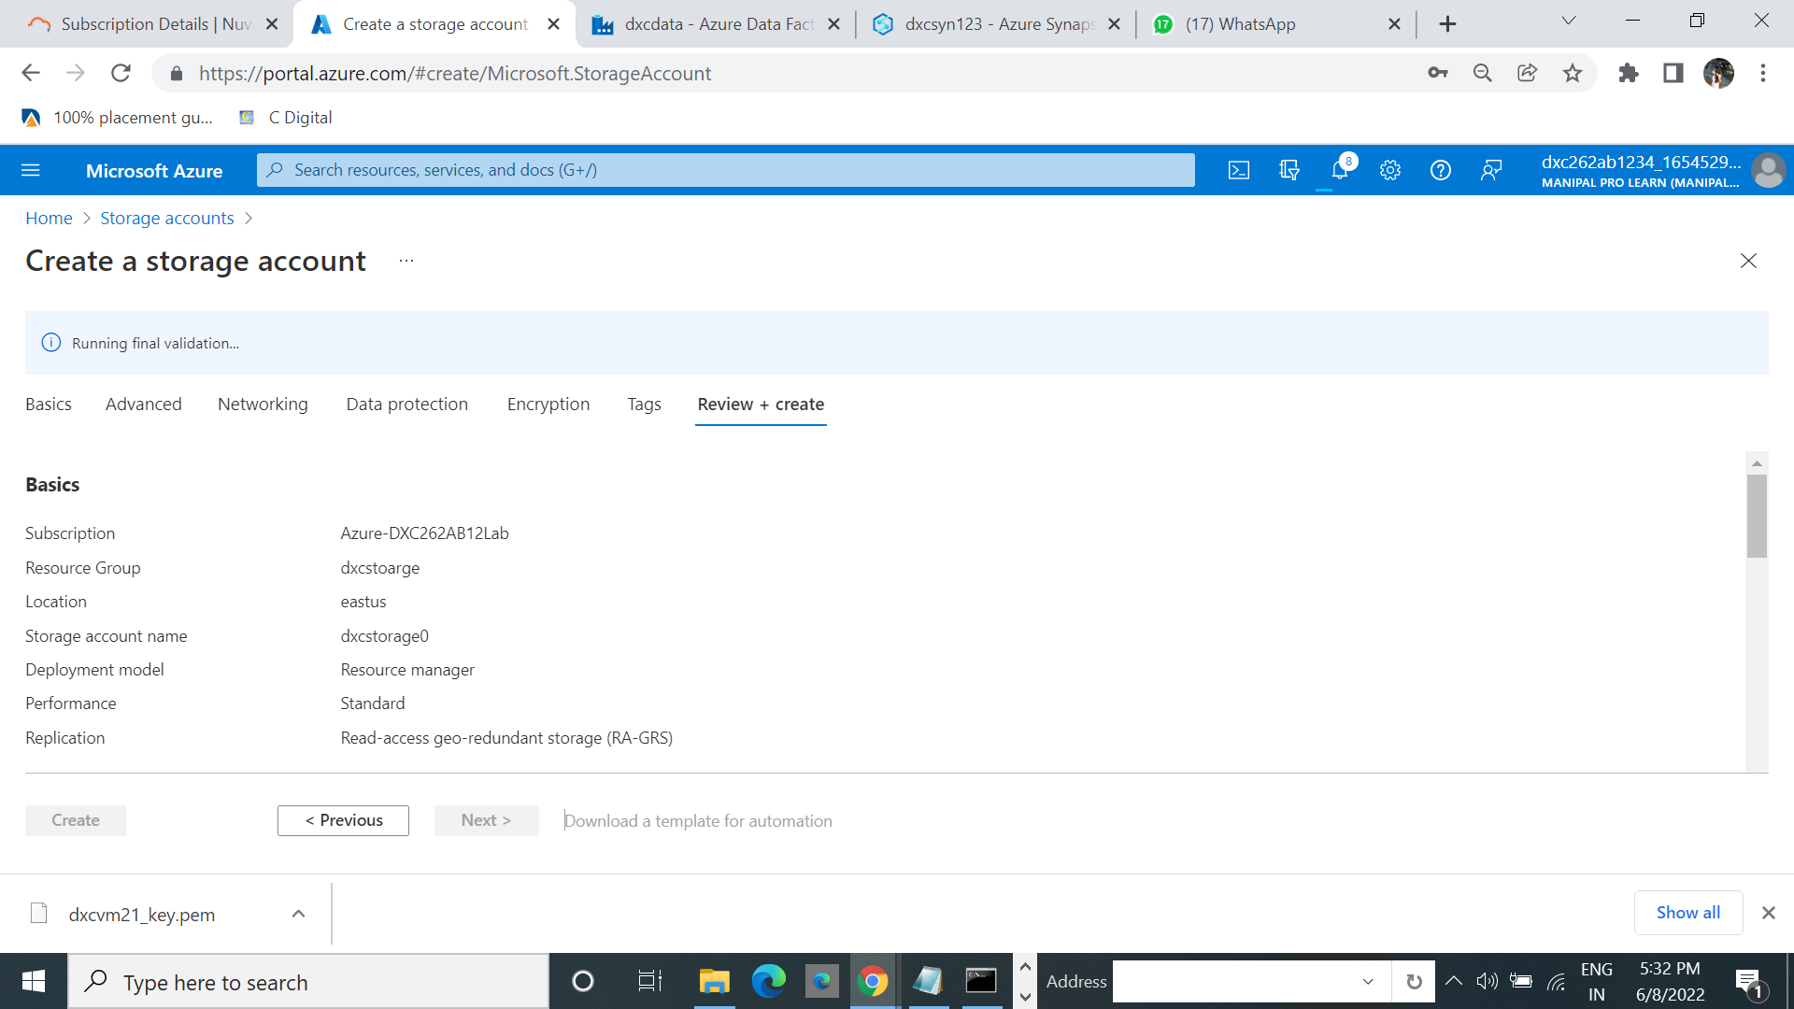

4.Click on create then it started deploying the files.

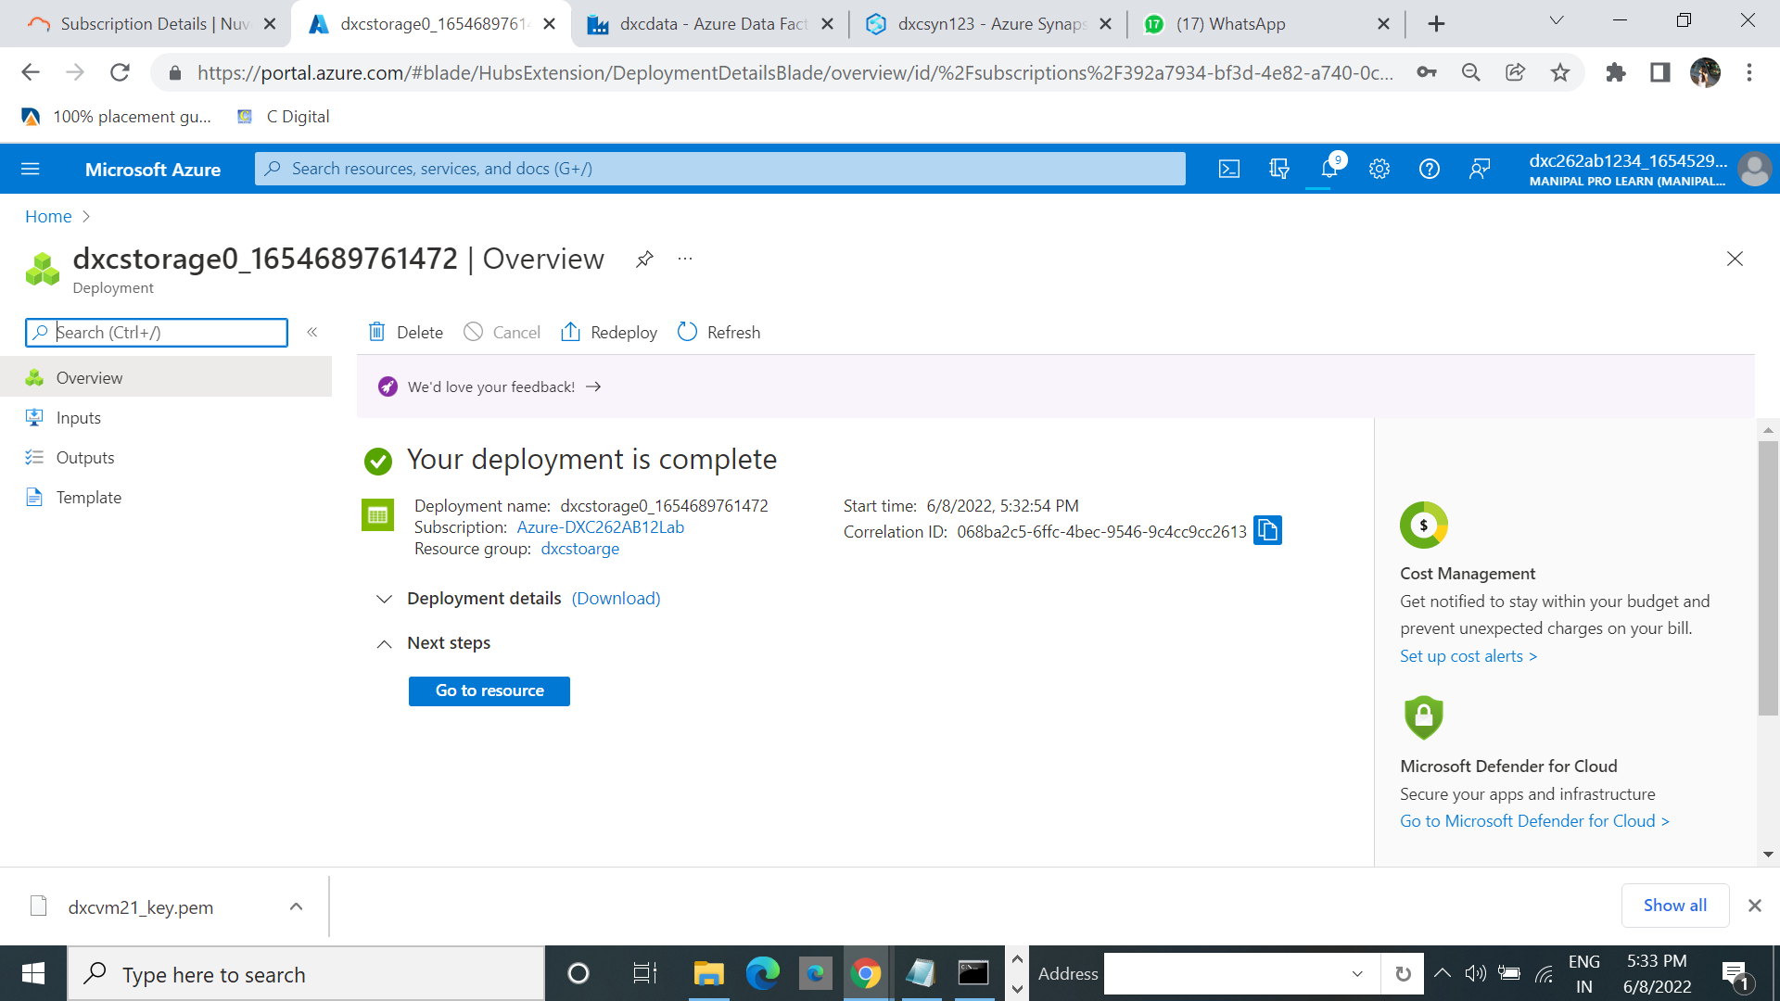

5.click on Go to resources.

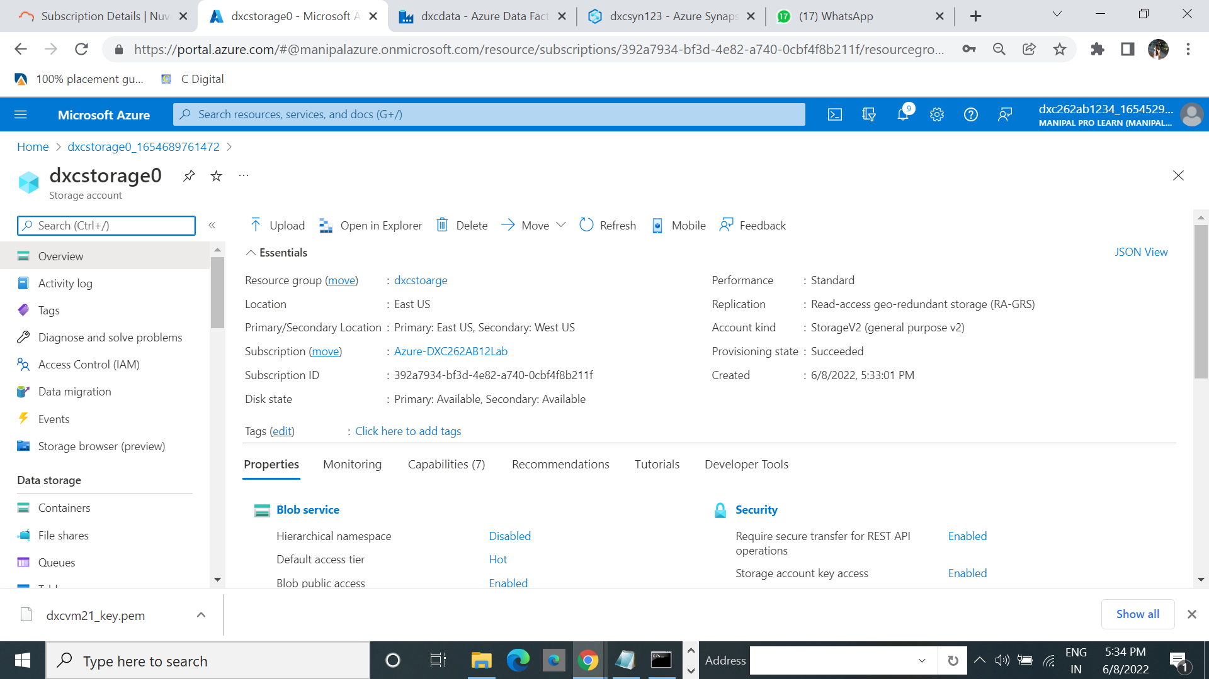

6.Click on the container. Create a new container.

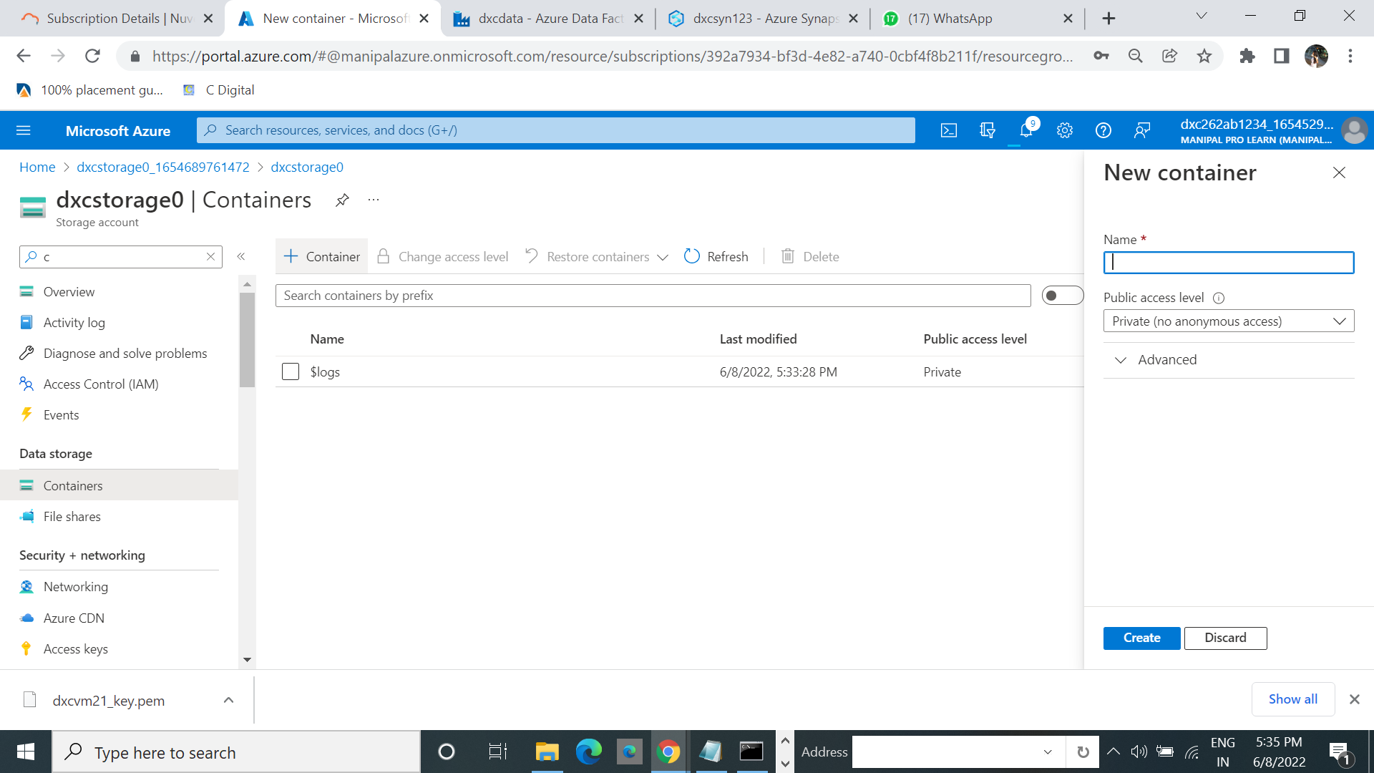

7.Successfully created the container.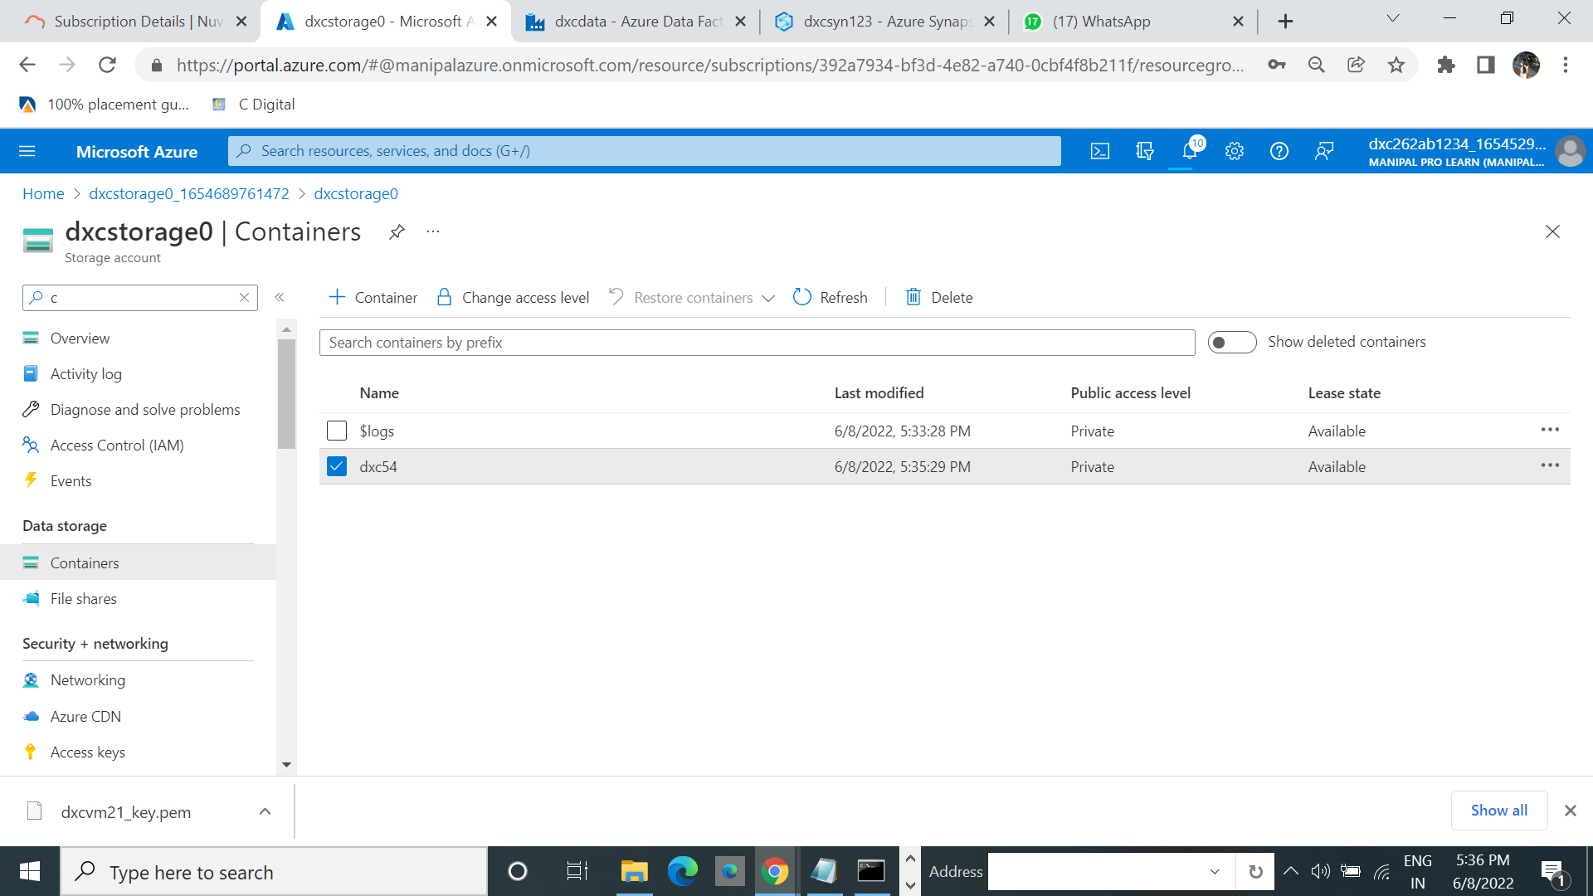

**8.Explain the steps with screenshots how to create upload data into Azure blobs ?**

**9.Explain the steps with screenshots how to create connect sql database in Azure ?**

1.Search for the sql database. Select and click on create.

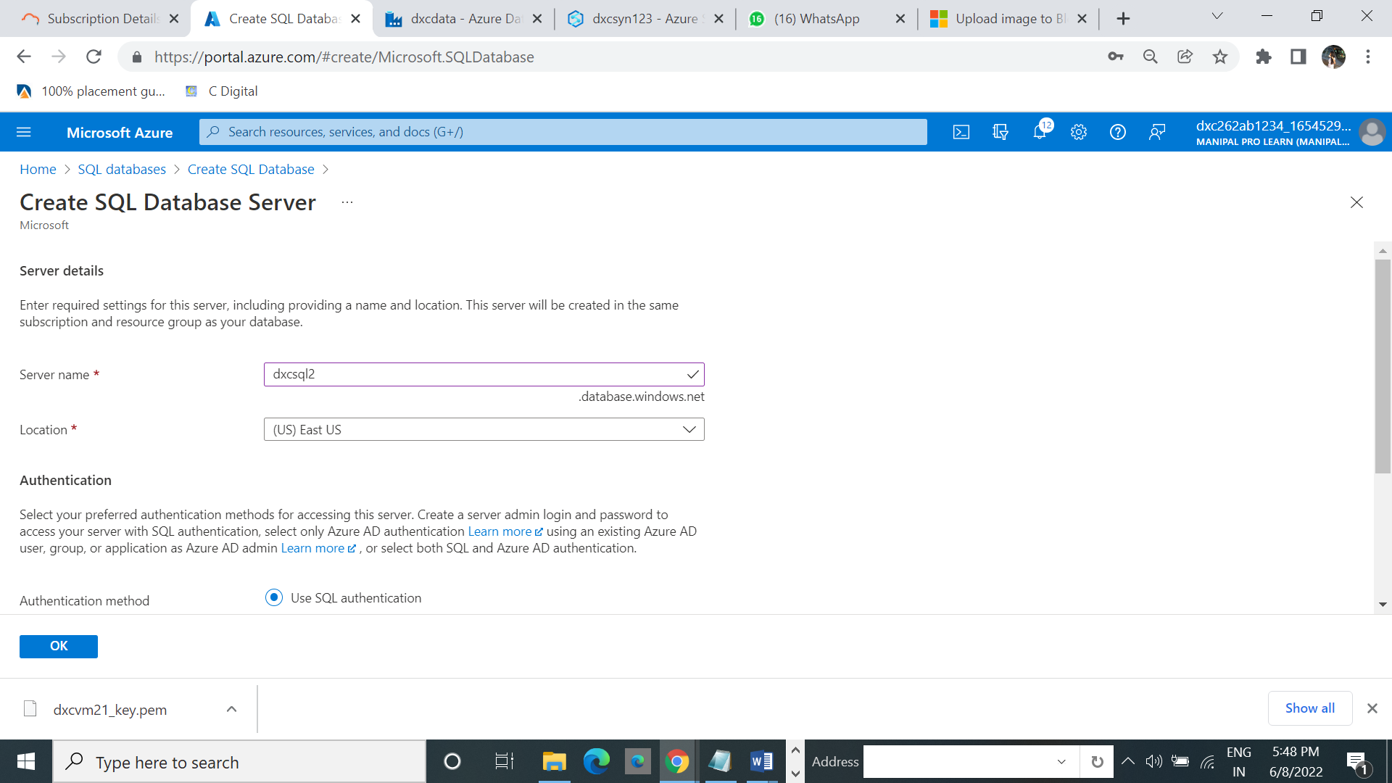

2. Browse to the [Select SQL Deployment option](https://portal.azure.com/#create/Microsoft.AzureSQL) page.

Under SQL databases, leave Resource type set to Single database, and select Create.

3. 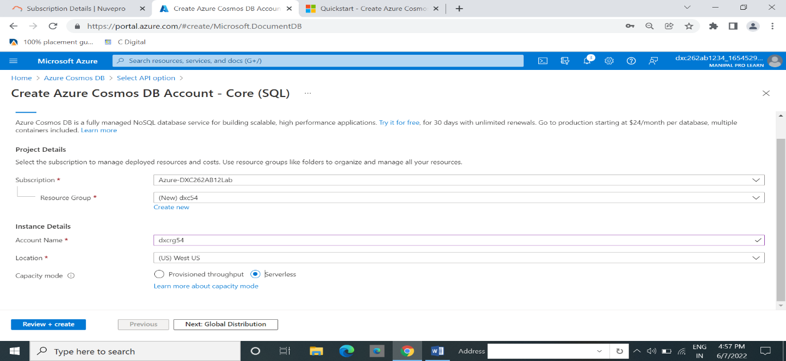

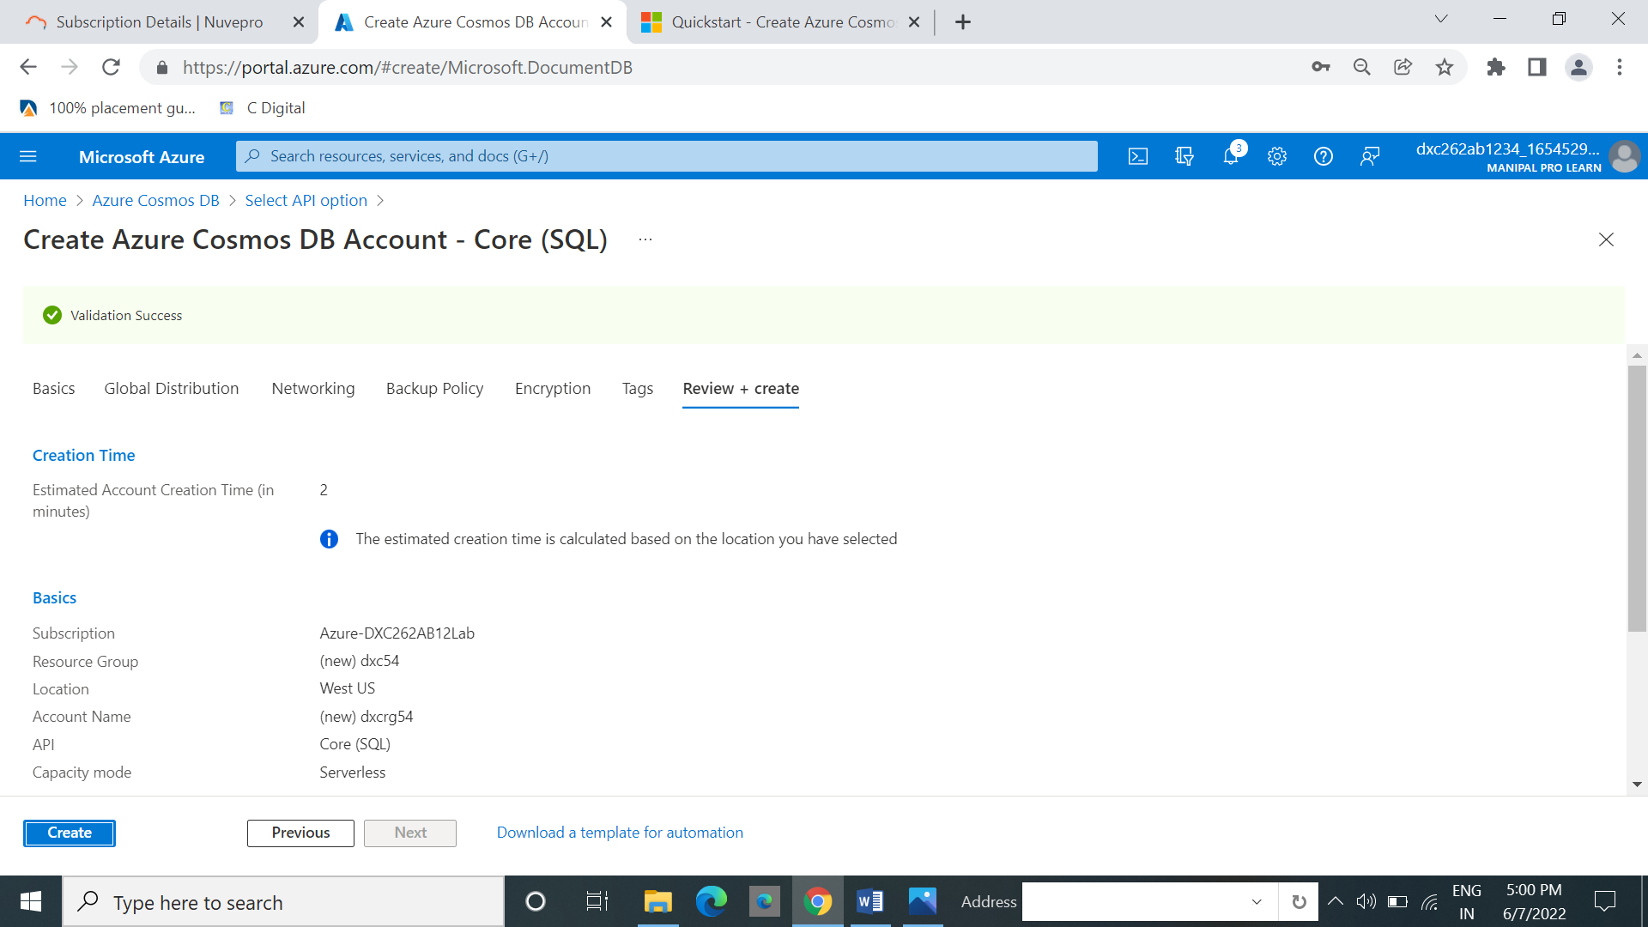

Select **Create.** It takes a few minutes to create the account. Wait for the portal page to display **Your deployment is complete.**

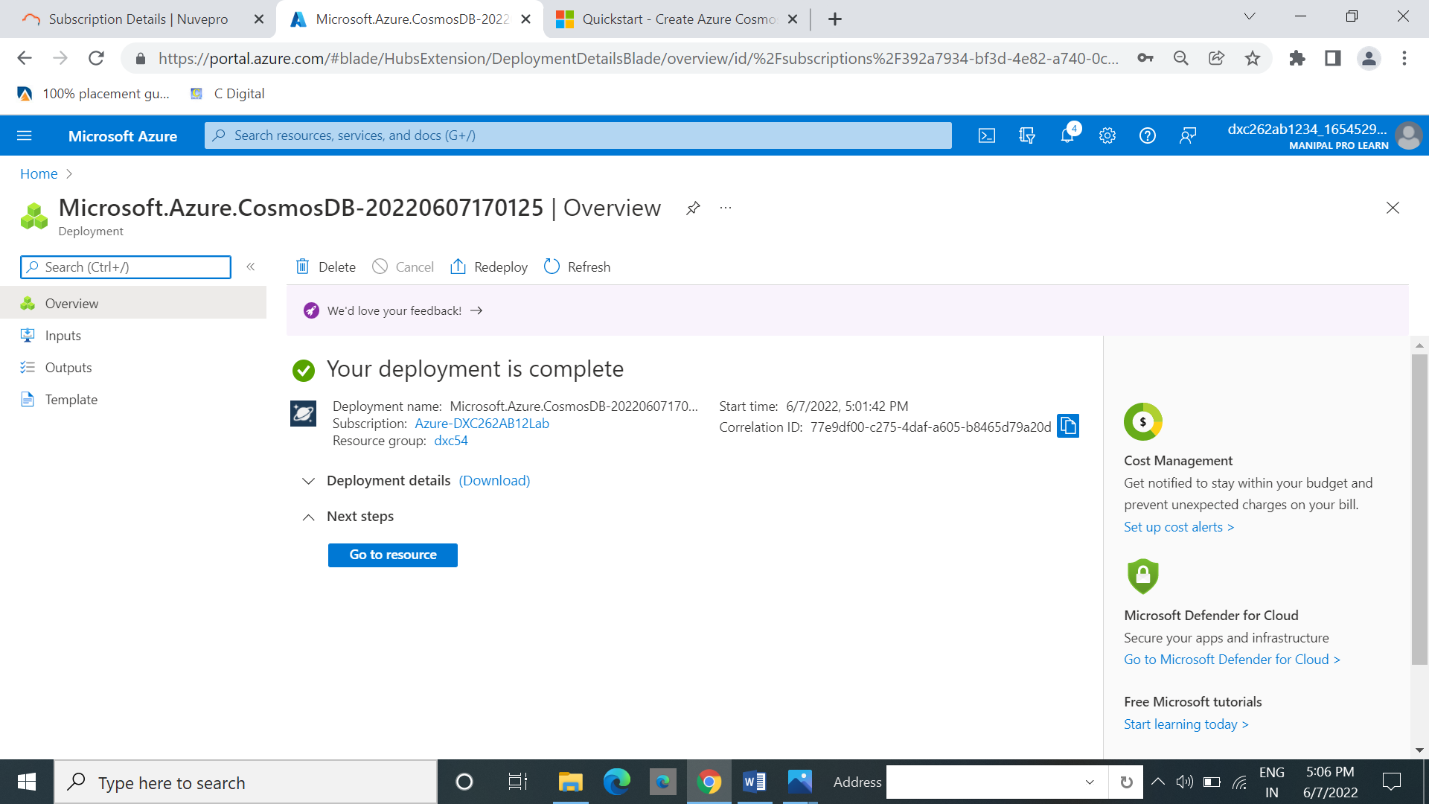

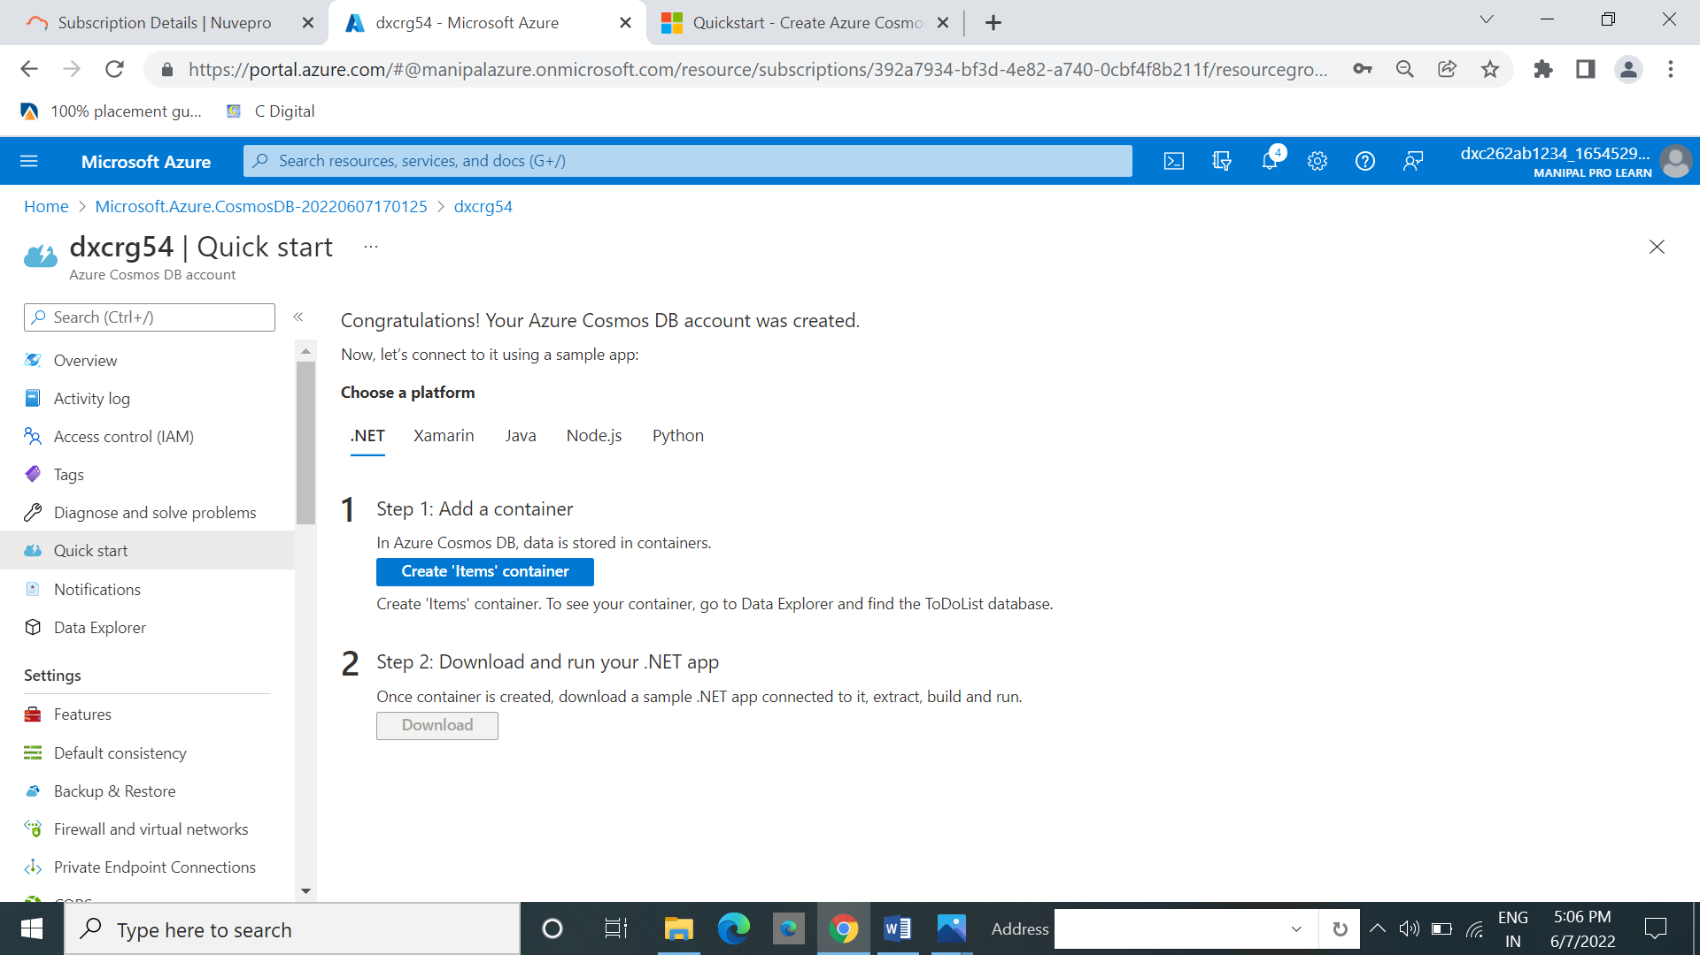

Select **Data Explorer** from the left navigation on your Azure Cosmos DB account page, and then select **New Container**

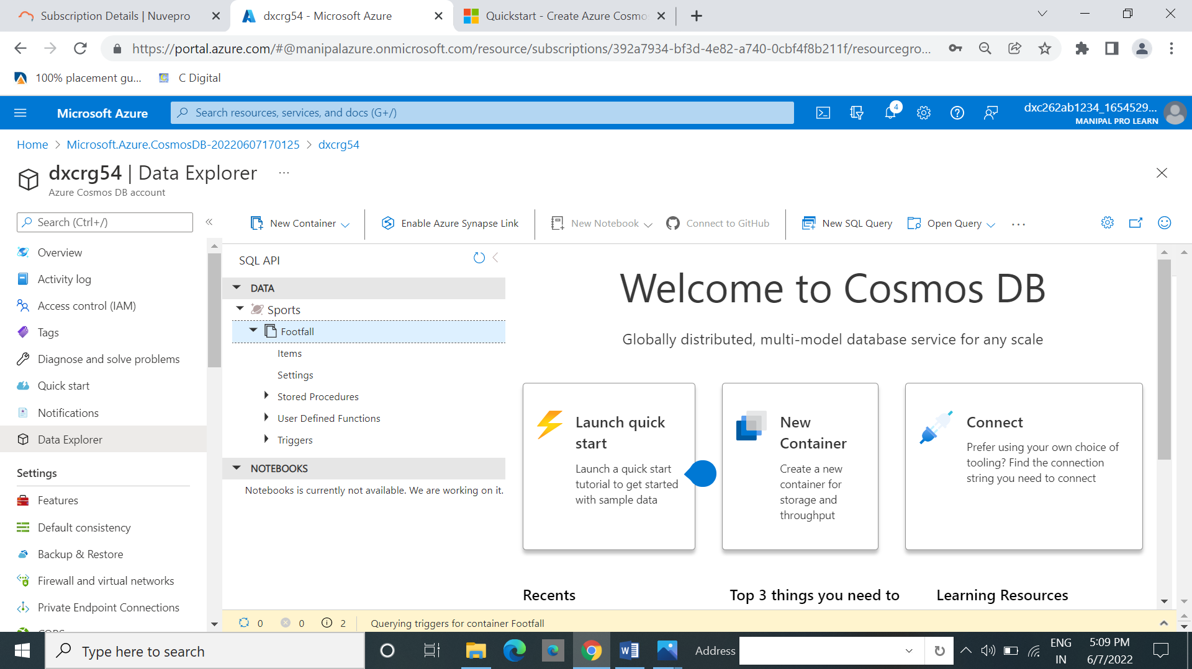

**10.Explain the steps with screenshots how to insert the data in sql database azure ?**

In data explore .The the data is present .we insert some data into it.

From that data select items. And then select new items.

